YEAR 7 TERM 3 (HALF TERM 2) KNOWLEDGE ORGANISER: WRITING A NARRATIVE INSPIRED BY A MIDSUMMER NIGHT’S DREAM OR THE TEMPEST
SIMPLE SENTENCES COMPOUND SENTENCES COMPLEX SENTENCES COMMAS COLONS SEMI-COLONS EXCLAMATION MARKS START WITH A VERB+ING START WITH AN ADVERBIAL
5 Types of Humour | The Four Worlds of AMND | The Tempest | WRITING A NARRATIVE  Narrative writing is writing that tells a story in a particular sequence that has a  beginning, middle and end.  INCLUDE  Varied sentence structures  Varied sentence starters  Varied punctuation  Varied and mature vocabulary  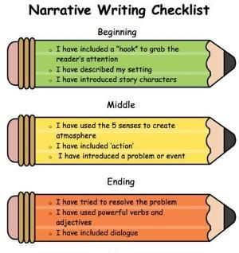
- Pun: play on words  - Earthy: a bit crude  - Slapstick: physical comedy  - Witty banter: quick and funny conversation  - Practical joke: playing a trick on someone to make them look silly  Ingredients of a good narrative:  You know the ending before you start writing  Include some detailed description Include some meaningful dialogue which tells the reader about characterization or action  Show not tell | World of the Athenians  Egeus is Hermia’s father and is very strict and law-abiding.  The Fairy Kingdom  Oberon and Titania are the Fairy King and Queen whose row sets off a chain of events. Puck is Oberon’s servant. He can make himself invisible and his magic causes trouble.  World of the Lovers  Demetrius – has consent to marry Hermia.  Lysander – secretly engaged to Hermia.  Helena - loves Demetrius.  Hermia - wants to marry Lysander and knows Hermia loves Demetrius.  The Mechanicals  These are the amateur actors including  Bottom, the victim of one of Puck’s tricks! | Meet the main characters:  Prospero: an ageing man banished from Naples and washed up by a storm (tempest) to the island.  Miranda: lives on the island with her father, Prospero. She has never met another human being.  Ariel: an island spirit who is enslaved to Prospero. .  Caliban: A monstrous, deformed creature who lives on the island. Antonio: He banished his brother Prospero from Naples and ends up landing on the island himself.  Alonso: King of Naples who plotted with Antonio to remove Prospero. Ferdinand: The son of the Alonso, who falls in love with Miranda.

