[](https://www.google.co.uk/url?sa=i&url=https://twitter.com/keslichfield&psig=AOvVaw34zpYdEy5yz8dJ1xX5sdJs&ust=1586535606177000&source=images&cd=vfe&ved=0CAIQjRxqFwoTCNCuku_f2-gCFQAAAAAdAAAAABAQ)

YEAR 8 TERM 3 **(half term 1)** KNOWLEDGE ORGANISER: Creative Writing

\|

**SENTENCE CONSTRUCTION TO IMPRESS**

* Varied, accurate punctuation
* Paragraphing – accurate use and linkage
* Introductory word and phrases
* Subordinate clause fronted complex sentence
* Simple sentence for impact
* Compound sentence
* Using parenthetic commas



TECHNIQUES TO IMPRESS

Strong adjective

Specific verbs

Similes/metaphors/personification

Alliteration

The five senses

Semantic field language

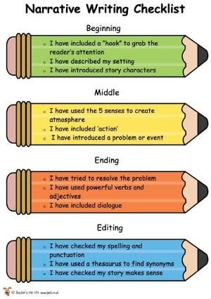

|  |  |  |  |
| --- | --- | --- | --- |
| **Ways to plan a story:**   * Mind map * Bullet point list * List with headings * Boxes * Spider diagram   Always aim for **five** paragraphs – one of them should be a single sentence paragraph. | **Ways to move a story on:**  *DROP:* The reader into the action.  *SHIFT:* To another time (e.g. flashback) or contrasting mood or alternative place.  *ZOOM IN:* On a tiny detail back where you started.  *ZOOM OU:* And leave the location.  *SINGLE SENTENCE PARAGRAPH:*  To focus the reader on something specific. Can go anywhere in the writing. | **Ways to prepare the describe**  **The Grid Method**  Divide the picture using a grid.  Then decide what to focus your writing on. | **Ways to prepare to describe**  **The Five Circles Method**  Circle five things to write about – these will become the focus for your five paragraphs. |

DO USE A SEMANTIC FIELD FOR EFFECT – DESCRIBING A SUPERMARKET AT XMAS USING THE LANGUAGE OF WAR

DO DESCRIBE SMALL THINGS IN GREAT DETAIL

DO RETURN TO THE START OF THE DESCRIPTION TO GIVE STRUCTURE

DO WRITE ABOUT SOMETHING BELIEVABLE

DO USE DIALOGUE TO DEVELOP CHARACTER

DO USE DIALOGUE TO DEVELOP ACTION

DO CHECK THAT THE STORY MAKES SENSE