[](https://www.google.co.uk/url?sa=i&url=https://twitter.com/keslichfield&psig=AOvVaw34zpYdEy5yz8dJ1xX5sdJs&ust=1586535606177000&source=images&cd=vfe&ved=0CAIQjRxqFwoTCNCuku_f2-gCFQAAAAAdAAAAABAQ)

Isolation

Strange noises

Ancient buildings

Supernatural

Darkness

Stormy weather

Death

Horror

‘The wind howled and the clouds cloaked the moon’

Dark – can’t see

Windy – nature is attacking

Cloudy – blocking out the moon and stars – the only source of light

= an atmosphere of danger and despair

QUESTION: HOW did the writer use LANGUAGE to create atmosphere?

**A question which has ‘HOW’ and ‘LANGUAGE’ in it is asking you to analyse word(s) by using PEE**

**Atmosphere - Writers create atmosphere by using carefully chosen:**

* **vocabulary (using strong adjectives and verbs e.g. anguish terror dread)**
* **language devices (figurative language, pathetic fallacy)**
* **punctuation (exclamation mark, ellipsis)**
* **sentence structures (short sentences for impact)**
* **setting (isolated, dark and ancient buildings)**

Atmosphere is how the reader feels as they are reading. In gothic horror, the writer may create an atmosphere of horror, fear, suspense, danger or terror.

Pathetic Fallacy: Using the weather to reflect the atmosphere.

[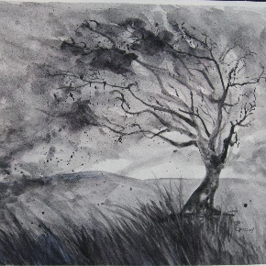](https://www.google.co.uk/url?sa=i&url=https://www.pinterest.com/pin/793970609285653581/&psig=AOvVaw0eZaUvTFm5p5YDGHAeVE6I&ust=1586872493699000&source=images&cd=vfe&ved=0CAIQjRxqFwoTCICB6fDG5egCFQAAAAAdAAAAABAJ)

Point: There is an atmosphere of danger and despair.

Evidence: ‘The wind howled and the clouds cloaked the moon’

Explanation: The writer used pathetic fallacy as he makes the wind sound like a predator about to chase down its prey. Furthermore, he makes the clouds sound as if they have deliberately thrown themselves over the moon in order to block out the light making the situation more dangerous as nothing can be seen.

**Victorian England – key facts**

* Gothic novels were at their most popular
* Victorians were very religious
* They were beginning to understand more through science
* They believed in the supernatural
* There was a strong class system
* There was great poverty with poor conditions in terms of housing and social welfare
* There was child labour and workhouses for the poor
* Education was becoming more common

Understanding the term genre and the range of genres that writers use e.g. horror, gothic horror, romance, crime, science fiction, dystopian.

Features of gothic horror: 

YEAR 7 TERM 2 (HALF TERM 1) KNOWLEDGE ORGANISER: STUDYING A GOTHIC TEXT