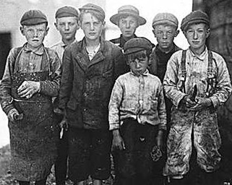[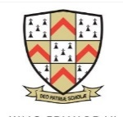](https://www.google.co.uk/url?sa=i&url=https://twitter.com/keslichfield&psig=AOvVaw34zpYdEy5yz8dJ1xX5sdJs&ust=1586535606177000&source=images&cd=vfe&ved=0CAIQjRxqFwoTCNCuku_f2-gCFQAAAAAdAAAAABAQ)

YEAR 8 TERM 2 KNOWLEDGE ORGANISER: Novel – Oliver Twist

LAYOUT OF AN ARTICLE

Title

Paragraphs – each one starts with a TOPIC SENTENCE

Language is formal

Structure response using:

Firstly,

Secondly,

Another point,

Furthermore,

Alternatively,

Finally,

CONTEXT: How old did children have to be to work in Victorian Times?

Victorian children would be made to go to work at a very young age. As unbelievable as it sounds, sometimes even 4 or 5 years old. Actually this was not unique only to the Victorian age, children had been expected to work for centuries before this. They worked very hard and for long hours every day. On the job safety was not a major concern and they were expected to work in filthy conditions many times. They really had no choice in the matter. Their parents made them work to help pay the bills at home. As they were considered cheap labour, Victorian children were in high demand for many types of jobs including mining, factory work, street sweepers, clothing and hat makers, chimney sweeps, farming, textile mills and servants.

**Charles Dickens CONTEXT**

Charles Dickens was born on February 7, 1812, in Portsea, England.

His parents were middle-class, but they suffered financially as a result of living beyond their means.

At age 12, Dickens was forced to quit school and work in a blacking factory, a place where shoe polish is made. The horrific conditions in the factory haunted him for life.

His father and his family were imprisoned for debt.

In nearly all his books he set out to attack some specific abuse or abuses in the existing system, championing the weak and oppressed.

One kind of character he often developed was the child as a victim of society.

THE WRITER’S PERSPECTIVE

The reader can decide how the writer feels about the topic she/he is writing about due to the choice of vocabulary used and the way it is expressed.

The writer may have any opinion and even change their opinion throughout the text. Examples are that the writer may feel *angry, optimistic, guilty, envious, admiring, amused* about the topic.

*‘Please, sir, I want some more.’*

*Oliver Twist by Charles Dickens.*

STRUCTURE OF A TEXT:

Why has the writer chosen to present his story in the order that he has and what effect does it have on the reader. Focus on:

* changes from a big focus to a small focus
* zooming out
* shifts of time
* shifts of topic
* shifts of person
* shifts of place
* sudden introductions or changes
* gradual introductions or changes
* flashbacks
* flash forwards
* foreshadowing
* external actions of characters
* internal thoughts of characters
* shifting point of view
* repetitions
* circular structures

CONTEXT: Victorian British society was divided into social classes:

The **aristocracy** were powerful and wealthy.

The **middle-class**, who ran the businesses, were ambitious and growing in wealth.

The **lower or working class poor** - in the villages, in the towns and working as servants in the homes of the rich – were very poor.

**CONTEXT**

**Workhouses** were where poor people who had no job or home lived. They earned their keep by doing jobs in the **workhouse**. Also in the **workhouses** were orphaned (children without parents) and abandoned children, the physically and mentally sick, the disabled, the elderly and unmarried mothers.