“With us it ain’t like that. We got a future. We got somebody to talk to that gives
a damn about us.”
“She smiled archly and twitched her body. "Nobody can't blame a person for lookin'," she said.”
"Curley's fist was swinging when Lennie
reached for it. The next minute Curley was flopping like a fish on a line.”
"…You go on get outta my room. I ain’t wanted in the bunk house, and you ain’t wanted in my room." "Why ain’t you
wanted?" Lennie asked. "’Cause I’m black…"
“And when they were gone, Candy squatted down in the hay and watched the face of
Curley's wife. "Poor bastard," he said softly.”
“Lennie said, "I thought you was mad at me, George."

"No," said George. "No, Lennie, I ain't mad. I never been mad, and I ain' now. That's a thing I want ya to know."

YEAR 9 TERM 1 (HALF TERM 1) KNOWLEDGE ORGANISER: ANIMALS – Modern Novel
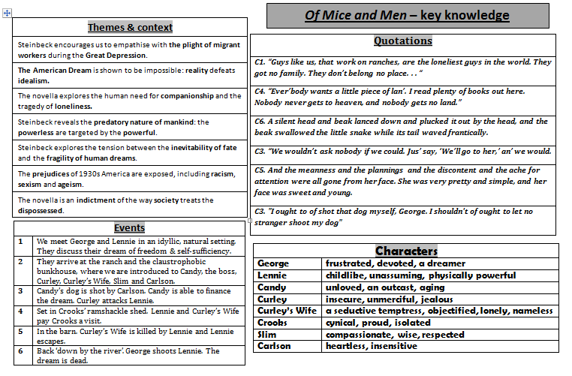
ANALYSIS =POINT + EVIDENCE + CONTEXT + EXPLANATION

Steinbeck’s Literary Devices |  | The Meaning of the Title
Simile | "Slowly, like a terrier who doesn't want to bring a ball to its master, Lennie  approached, drew back." (p9) | The title of the book is derived from a poem by the 18th Century Scottish poet: Robert Burns.  In the poem, a mouse carefully builds a nest in a wheatfield, yet it is destroyed when the field is ploughed. The mouse had looked forward to a comfortable and prosperous future, only to have its dreams crushed – much like George and Lennie. It is written in a Scottish dialect:  The best laid schemes o' mice an' men Gang aft a-gley,  An' lea'e us nought but grief an' pain, For promised joy!
Personification | "The sycamore leaves whispered in a little night breeze." (p16).
Metaphor | "Lennie covered his face with huge paws and bleated with terror." (p63)
Foreshadowing | The shooting of Candy’s dog foreshadows the shooting of Lennie. Lennie killing animals foreshadows him killing people.

