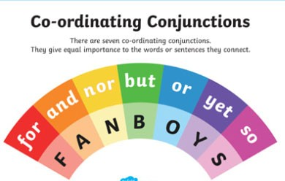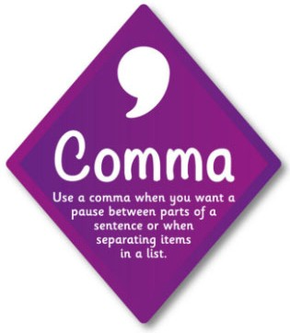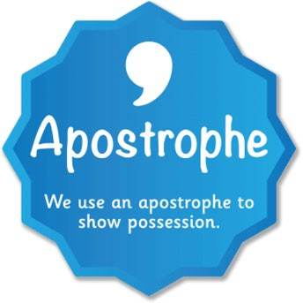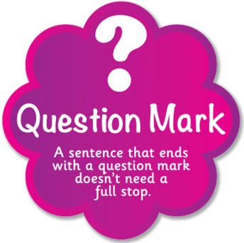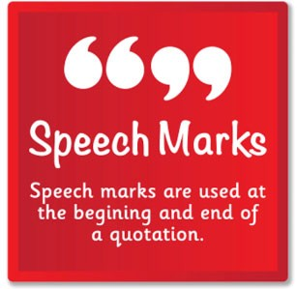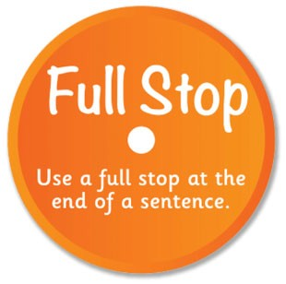[](https://www.google.co.uk/url?sa=i&url=https://twitter.com/keslichfield&psig=AOvVaw34zpYdEy5yz8dJ1xX5sdJs&ust=1586535606177000&source=images&cd=vfe&ved=0CAIQjRxqFwoTCNCuku_f2-gCFQAAAAAdAAAAABAQ)

**Sentence structures**

**Simple: One noun, one verb:**

**Compound: Two complete sentences joined by a co-ordinating conjunction:**

**Complex sentences: Sentence has a MAIN clause and a SUBORDINATE clause. The subordinate clause can be at the beginning, middle or end of the sentence**

**DESCRIPTIVE TOOL KIT**

Strong adjective:

The ravenous child

Specific verbs:

The teacher bellowed.

Figurative language:

Similes

Her smile was like sunshine

Metaphors

The man was a mountain

Personification

The trees danced in the wind

Alliteration:

The wide, wandering river

The five senses:

Touch, taste, hear, see and smell

LITERAL MEANING OF WORDS = THE EXACT MEANING OF WHAT A WORD MEANS

IMPLIED MEANING OF WORDS = THE IDEAS WHICH THE READER ASSOCIATES WITH THE WORDS

Language we use to discuss implied meaning:

Implies/implied/implying

Suggests/suggested/suggesting

Infers/inferred/inferring

Use the PEE structure in your paragraphs talking about inferred meaning

Point – state a characteristic or something we deduce about a character.

Evidence – use a key piece of evidence from the text. Introduce with a comma and use quote marks.

Explanation – explain the connection between the point and the evidence - HOW it is suggested. You can use more than one piece of evidence to support your point but each must be explained.

EXAMPLE

The word AMBLE literally means to walk leisurely.

The writer shows that the character does not want to go to school, ‘John ambled to school’. By using this word to describe how he walked, the writer is suggesting that the boy is moving slowly and trying to put off actually getting to school.

YEAR 7 TERM 1 KNOWLEDGE ORGANISER: STUDYING LANGUAGE IN A MODERN TEXT