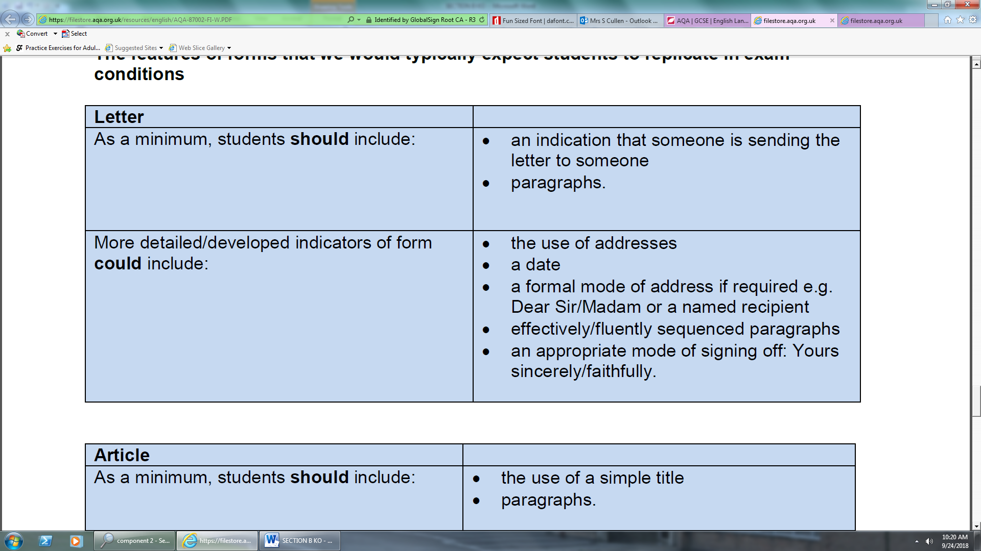

|  |  |
| --- | --- |
| **Web Article (blog)** |  |
| As a minimum, students **should** include | * the use of a simple title * paragraphs |
| More detailed/developed indicator of **could** include | * A clear original title * A strapline * Subheadings * An introductory paragraph * Fluent, linked paragraphs * A more light-hearted approach * Reference to the website |

[](https://www.google.co.uk/url?sa=i&rct=j&q=&esrc=s&source=images&cd=&cad=rja&uact=8&ved=2ahUKEwi8w-HqqdPdAhWuyYUKHfwBAgMQjRx6BAgBEAU&url=https://poetsandquants.com/2015/08/13/verdict-years-business-school-mba-essays/&psig=AOvVaw010c0geUukM8ZR5u2zL2eI&ust=1537867696930559)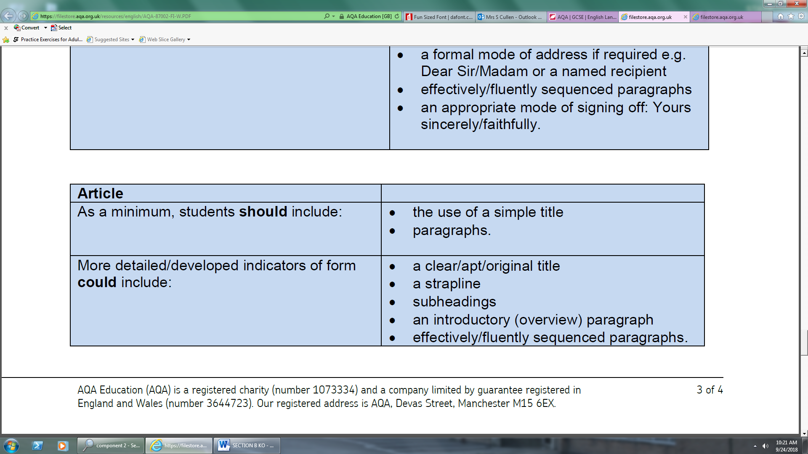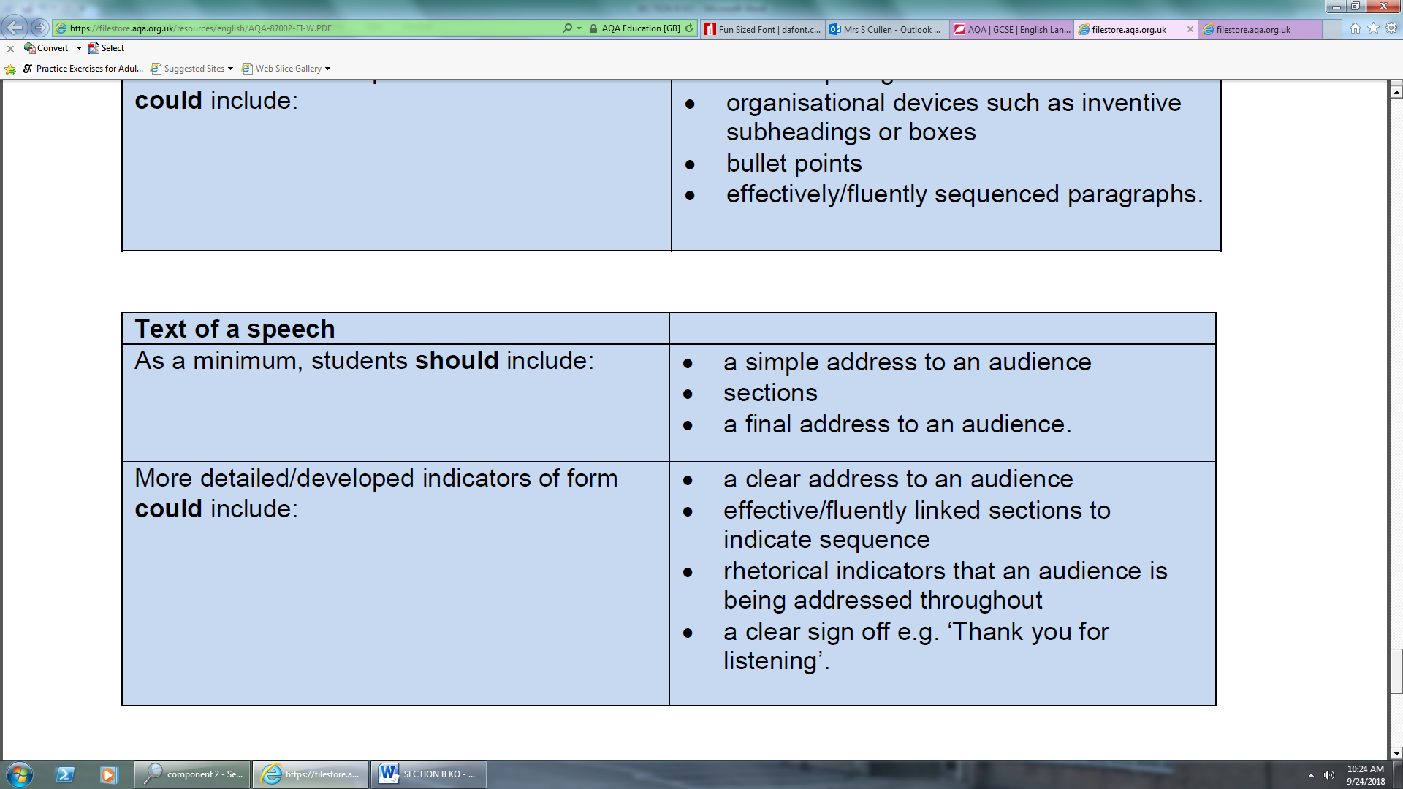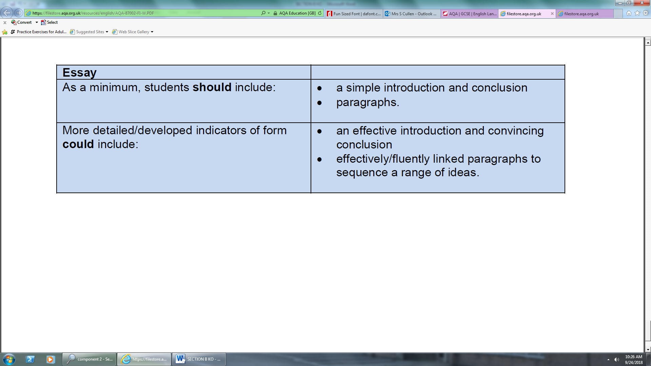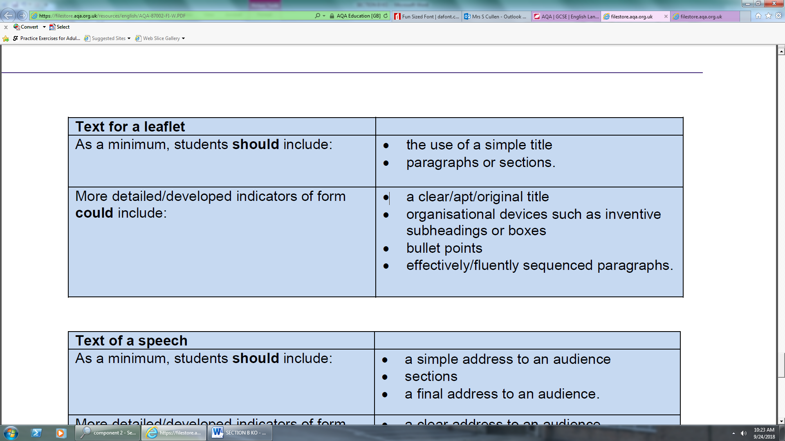[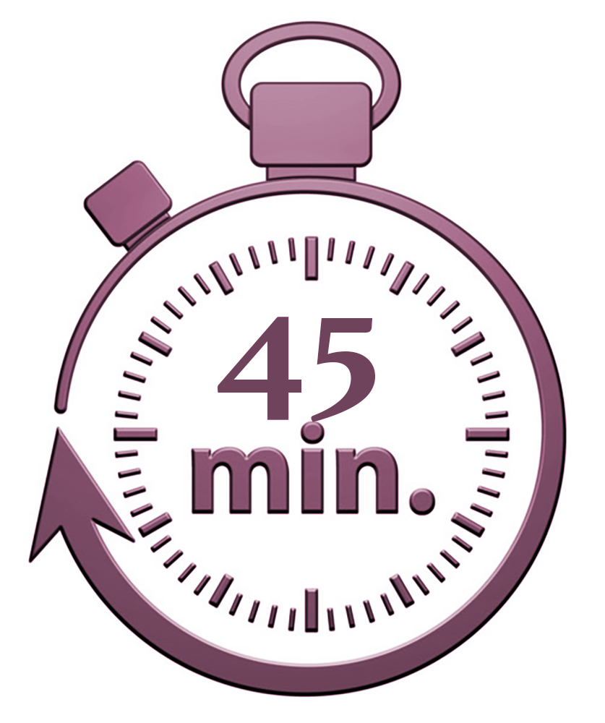](http://www.google.co.uk/url?sa=i&rct=j&q=&esrc=s&source=images&cd=&cad=rja&uact=8&ved=2ahUKEwjdprGxn9PdAhVR2aQKHWVqABgQjRx6BAgBEAU&url=http://www.parboldequestriancentre.co.uk/product/shared-private-lesson-30-minutes/&psig=AOvVaw1zk4OQ8gj3d0Cid6a93M2C&ust=1537864884668431)[](https://www.google.co.uk/url?sa=i&rct=j&q=&esrc=s&source=images&cd=&cad=rja&uact=8&ved=2ahUKEwiIy9-IntPdAhUMyaQKHT7HCF0QjRx6BAgBEAU&url=https://steamcommunity.com/workshop/filedetails/?id%3D685830475&psig=AOvVaw0MH7SIOtCems2xJ8rHqKAW&ust=1537864535890205)

The Tasks

* You will be given ONE extended writing task to complete.
* This task will have a specific audience, purpose and form
* The focus of the task will link to the reading material in section A
* It will usually begin with a statement or quote that you then offer your own opinion/perspective on

Examples of purpose

* Writing to argue, persuade, advise, explain, instruct

Examples of forms

* article, speech, web article, letter, essay, text for a leaflet
* ***OTHER TECHNIQUES YOU CAN USE TO AFFECT YOUR AUDIENCE***
* **Lists**
* **Use of humour**
* **Imagery**
* **Level of formality, including informality for effect**
* **Juxtaposition of contrasts/opposites (The people of Africa are starving; households in the U.K wastes an estimated of food a week)**
* **Range of connectives**
* Discourse markers

Paragraphing and structural features

* Discourse markers to organise writing and show coherence between sentences, phrases and paragraphs
* Paragraphs need to be clear
* If you change the topic, place, person or time, then you need to change your paragraph too!
* Link paragraphs to show the flow of your writing and how one moves on to the next. You could repeat a key phrase/ word/idea from the previous paragraph, or show a continuation of an idea.
* Make a connection or link between the opening and closing paragraphs
* Use single sentence paragraphs for effect

Effective Persuasive Techniques to use

A FORESTER’S CAP

A – ALLITERATION

F – FACTS

O – OPINION

R - RHETORICAL QUESTION

E – EXAGGERATION

S – STATISITICS

T – TRIPLET

E – EMOTIVE LANGUAGE

R – REPETITION

S – SUPERLATIVES

C – COUNTER ARGUMENT

A – ANECDOTES

P – PERSONAL PRONOUN

[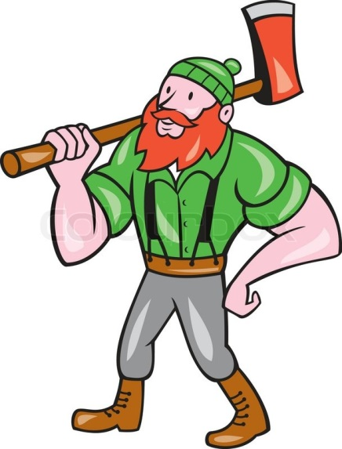](https://www.google.co.uk/url?sa=i&rct=j&q=&esrc=s&source=images&cd=&cad=rja&uact=8&ved=0ahUKEwiS_oKhgdLMAhVIPBoKHWhSDAcQjRwIBw&url=https://www.colourbox.com/vector/paul-bunyan-lumberjack-isolated-cartoon-vector-11234987&bvm=bv.121658157,d.d2s&psig=AFQjCNHC6n_iE2qHeUEpBOilRGZPeRKXFA&ust=1463055647312245)

**AO6**

**AO5**

Assessment Objectives

* Communicate clearly and imaginatively
* Write in the correct style and form for the task
* Use the appropriate techniques/linguistic devices for the style of writing
* Write with the appropriate tone and register for the target audience
* Organise ideas logically and for effect to make sure writing is clear and coherent
* Use clear, linked paragraphs and other structural features.
* Use a range of effective vocabulary
* Use a range of sentence structures for effect
* Vary sentence starters
* Use a wide range of accurate punctuation
* Accuracy in spelling

Vary your sentence starters

Start sentences with a range of:

* Adverbs
* Verbs
* Connectives
* Prepositions

And remember, starting with one of these types of words can create complex sentences, which means a comma will need to go somewhere in the sentence to separate the man and subordinate clause.

Some basic punctuation tips:

* **Commas to separate**: items in a list, before a FANBOYS conjunction, to introduce speech, to separate two adjectives, after an introductory word or phrase, and to separate the main/subordinate clauses in a sentence
* **Full stops** to indicate the end of the sentence
* **Capital letters** for proper nouns and at the start of new sentences (including ‘I’)
* **Apostrophes** for omissions of letters (can’t, didn’t, couldn’t)
* **Apostrophes** to show possession (exception ‘its’)
* **Exclamation marks** to indicate loud noise, shouting, commands and extreme emotion
* **Semi colons** to replace a full stop where there is a strong link/connection between sentences. Follow the rules:
* The semi colon replaces words like as and because
* The two phrases either side of the semi colon must make sense on their own (main clauses)
* One phrase needs to be a consequence of the other
* E.g. the football match has been cancelled; the weather forecast is terrible.
* **Colon** – used to introduce a list (no ‘and’) or single word for emphasis