|  |
| --- |
| **QUESTION ONE**  **CHOOSE** four true or false statements from a list of 8.   * 4 marks = 5 mins (4 boxes shaded) * Named lines * AO1 – find & inference |
| **QUESTION TWO**  Write a **SUMMARY** of the **DIFFERNCES** between Source A and B   * 8 marks = 10mins * Two texts * AO1 – summarise differences |
| **QUESTION THREE**  How does the writer use **LANGUAGE** to…” in one source only   * 12 marks = 20 mins * One text * AO2 – Language (not structure) |
| **QUESTION FOUR**  **Compare** **DIFFERENCES** in **LANGUAGE** in how the two **writers** present/convey/convince/persuade… in Source A and B   * 16marks = 25mins * Two texts * AO3 – compare language (not structure) |

**QUESTION FOUR : Writer’s viewpoint/opinion/perspective**

**Does his/her use of language make you that the topic makes them feel:**

|  |  |  |  |
| --- | --- | --- | --- |
| **Amused**  **Sarcastic**  **Annoyed**  **Furious** | **Guilty**  **Bemused**  **Incensed**  **Jubilant** | **Pessimistic**  **Optimistic**  **Envious**  **Miserable** | **Relaxed**  **Full of energy**  **Admiring**  **Inspired** |

**Do they use language to persuade the reader to feel the same by using techniques such as:** FORESTER’S CAP

A – ALLITERATION

F – FACTS

O – OPINION

R - RHETORICAL QUESTION

E – EXAGGERATION

S – STATISITICS

T – TRIPLET

E – EMOTIVE LANGUAGE

R – REPETITION

S – SUPERLATIVES

C – COUNTER ARGUMENT

A – ANECDOTES

P – PERSONAL PRONOUN

THE QUESTIONS

**QUESTION THREE: Analysing language**

* Word choices used by the author – what do the words mean? What do they make you think of (their **connotations**)? What word class do they belong to?
* Techniques/linguistic devices – identify them and consider their purpose, use and effect
* Punctuation and sentence structures – do they change the way you read the piece? Does it tell us about the tone in which something is communicated? Does it make us read the text faster or slower?



How do writers CONVEY their ideas?

Using a different format personal letter v public article

Using quotes

Using descriptive language

Using factual language

Using hyperbole

Using short sentences for impact

Using persuasive techniques

Using humour (tongue in cheek)

Using lists

Addressing the reader directly

[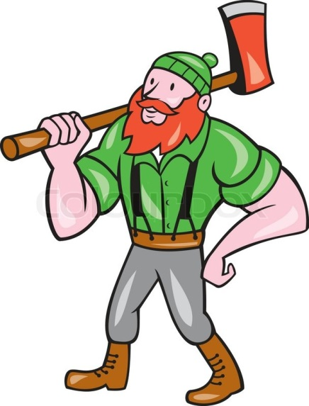](https://www.google.co.uk/url?sa=i&rct=j&q=&esrc=s&source=images&cd=&cad=rja&uact=8&ved=0ahUKEwiS_oKhgdLMAhVIPBoKHWhSDAcQjRwIBw&url=https://www.colourbox.com/vector/paul-bunyan-lumberjack-isolated-cartoon-vector-11234987&bvm=bv.121658157,d.d2s&psig=AFQjCNHC6n_iE2qHeUEpBOilRGZPeRKXFA&ust=1463055647312245)

EXPLODE A WORD

Some Linguistic Devices

* Direct and indirect speech
* Figurative language
* Imagery
* Emotive language
* Hyperbole
* Strong verbs and adjectives
* Words chosen to give not just literal but **IMPLIED meaning**

[](https://www.google.co.uk/url?sa=i&rct=j&q=&esrc=s&source=images&cd=&cad=rja&uact=8&ved=0ahUKEwiS_oKhgdLMAhVIPBoKHWhSDAcQjRwIBw&url=https://www.colourbox.com/vector/paul-bunyan-lumberjack-isolated-cartoon-vector-11234987&bvm=bv.121658157,d.d2s&psig=AFQjCNHC6n_iE2qHeUEpBOilRGZPeRKXFA&ust=1463055647312245)

EXPLODE A QUOTE

Question 4: Compare how writers present… **Top Tips **

* Write about the writers’ perspective and point of view, not the readers’.
* Consider their attitudes and emotions towards the topic/focus of the question and HOW they present these feelings.
* Evidence to support your answer are needed.
* Analysis of evidence is needed.
* Compare the extracts, don’t simply cross reference.
* Don’t talk about one text and then the other. ‘Interweave’ your discussion of the texts

Consider comparing the use/effect of:

* Word choices
* Rule of three and lists
* Rhetorical questions
* Tone of writing – serious, factual, opinion based, humorous, etc.
* Imagery
* Sentence structures
* Development of ideas across the text – is there a sense of building ideas or change in tone/feelings/emotions across the text?
* The way the extract is written – a diary entry, a letter, an interview, a biography or autobiography. Why might these have an effect on how it is written?
* When was it written and in what context

**And finally:**

**Think back to the way you compare poems on the English Literature paper: the same skills apply!**

Question 2: Write a summary

**Top Tips **

* Synthesis means to combine things in order to create something whole.
* In this question, you are expected to combine the two texts in order to summarise the information in them.
* **You will not need to analyse quotations** so don’t ‘zoom in’ on key words or techniques
* You will need to make inferences (look at the implied meaning, not the obvious/explicit ideas) and use embedded quotations to support your comments
* You are comparing the texts for their overall tone/message. Use phrases like more/less or superlatives

e.g.: ‘text a is more sympathetic than text b as shown when…’

‘text a is less formal than text b, showing that…’

Question 3: How does the writer use of language…

**Top Tips** 

- Here, you are looking at what the author has done to create meaning. This means you should be looking at:

- Word choices used by the author (their meaning and connotations)

- Techniques used by the author and their effect

- **Don’t write out overlong quotations and zoom into them**. You are better to use single word quotations/smaller phrases and discuss the meaning and effect of those word choices

- You will be looking for information that is suggested, not obviously said.

- Link all explanations back to the wording of the question

- Look for patterns in word choices and the overall /cumulative effect of them

- It is not a test on your knowledge of subject terminology. Instead, the focus is on the **effect** of what is used.

- Focus on what the writer intended, not the reader.

- Do not discuss effect of punctuation or sentence structures, **focus on language**.

Some useful phrases:

The use of the word…implies

The semantic filed of…suggests…

The repeated use of…highlights the writer’s…

The effect of this personal pronoun is to show…

AO1

Question 1: True/false statements

**Top Tips **

* No need for any long written answers, simply shade in the appropriate box for your answer
* Read the question very carefully as some of the statements will deliberately try to catch you out
* You will need to identify explicit and implicit information
* Only refer to the lines of the extract that are outlined in the question.

AO3

AO1

AO2