[](https://www.google.co.uk/url?sa=i&rct=j&q=&esrc=s&source=images&cd=&cad=rja&uact=8&ved=2ahUKEwiIy9-IntPdAhUMyaQKHT7HCF0QjRx6BAgBEAU&url=https://steamcommunity.com/workshop/filedetails/?id%3D685830475&psig=AOvVaw0MH7SIOtCems2xJ8rHqKAW&ust=1537864535890205)[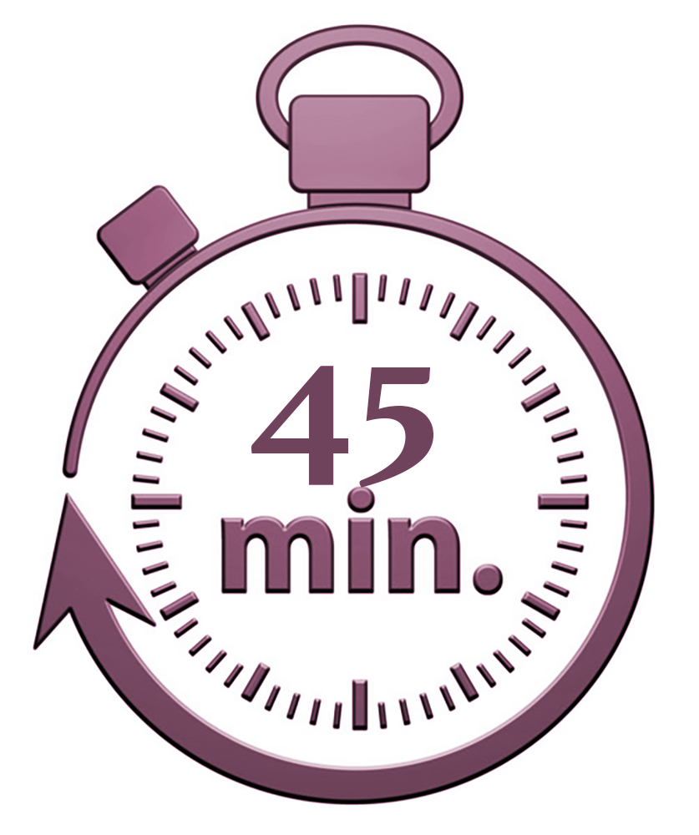](http://www.google.co.uk/url?sa=i&rct=j&q=&esrc=s&source=images&cd=&cad=rja&uact=8&ved=2ahUKEwjdprGxn9PdAhVR2aQKHWVqABgQjRx6BAgBEAU&url=http://www.parboldequestriancentre.co.uk/product/shared-private-lesson-30-minutes/&psig=AOvVaw1zk4OQ8gj3d0Cid6a93M2C&ust=1537864884668431)

Assessment Objectives

* Communicate clearly and imaginatively
* Write in the correct style and form for the task
* Use the appropriate techniques/linguistic devices for the style of writing
* Write with the appropriate tone and register for the target audience
* Organise ideas logically and for effect to make sure writing is clear and coherent
* Use clear, linked paragraphs and other structural features.
* Use a range of effective vocabulary
* Use a range of sentence structures for effect
* Vary sentence starters
* Use a wide range of accurate punctuation
* Accuracy in spelling

The Tasks

You will be given the choice of two different tasks:

Writing to describe: you may be given a picture or a situation as a stimulus for a piece of writing.

Narrative writing: You may be asked to write a short story about a certain situation or type of people.

ONLY COMPLETE ONE OF THESE TASKS!

Plan your structure

* Are you going to have a cyclical structure, where the opening links to the end?
* Are you going to use flashback?
* Think about your ‘big idea’ and how you will arrive at it as a destination.
* - How the text opens
* How the text ends
* Any recurring ideas, themes or images in your writing
* What changes or what doesn’t throughout your writing

Vary your sentence starters

Start sentences with a range of:

* Adverbs
* Verbs
* Connectives
* Prepositions

And remember, starting with one of these types of words can create complex sentences, which means a comma will need to go somewhere in the sentence to separate the man and subordinate clause.

Some basic punctuation tips:

* **Commas to separate**: items in a list, before a FANBOYS conjunction, to introduce speech, to separate two adjectives, after an introductory word or phrase, and to separate the main/subordinate clauses in a sentence
* **Full stops** to indicate the end of the sentence
* **Capital letters** for proper nouns and at the start of new sentences (including ‘I’)
* **Apostrophes** for omissions of letters (can’t, didn’t, couldn’t)
* **Apostrophes** to show possession (exception ‘its’)
* **Exclamation marks** to indicate loud noise, shouting, commands and extreme emotion
* **Semi colons** to replace a full stop where there is a strong link/connection between sentences. Follow the rules:
* The semi colon replaces words like as and because
* The two phrases either side of the semi colon must make sense on their own (main clauses)
* One phrase needs to be a consequence of the other
* E.g. the football match has been cancelled; the weather forecast is terrible.
* **Colon** – used to introduce a list (no ‘and’) or single word for emphasis

Paragraphing and structural features

* Discourse markers to organise writing and show coherence between sentences, phrases and paragraphs
* Paragraphs need to be clear
* If you change the topic, place, person or time, then you need to change your paragraph too!
* Link paragraphs to show the flow of your writing and how one moves on to the next. You could repeat a key phrase/ word/idea from the previous paragraph, or show a continuation of an idea.
* Make a connection or link between the opening and closing paragraphs
* Use single sentence paragraphs for effect

Effective techniques to use

Sentence structures (simple, compound, complex)

Sentence lengths

Repetition

Semantic field of language

Alliteration

Figurative language (metaphor, simile, personification)

Onomatopoeia

Structure (hints/clues, building detail, withholding info)

The 5 senses (smell, taste, touch, hear, see)

Zoom in

Powerful vocabulary

Pathetic fallacy

Suggest, don’t tell (make the reader use their imagination!

**AO6**

**AO5**