**When we analyse a text, we are looking at the following:**

* Word choices used by the author – what do the words mean? What do they make you think of (their connotations)? What word class do they belong to?
* Techniques/linguistic devices – identify them and consider their purpose, use and effect
* Punctuation and sentence structures – do they change the way you read the piece? Does it tell us about the tone in which something is communicated? Does it make us read the text faster or slower?

**Words to show interpretation and critical response:**

Suggests Effectively

Implies Successfully

Indicates Essentially

Highlights Cleverly

Demonstrates Clearly

Conveys

Evokes

Symbolises

Refers to

Exaggerates

Connotes

Represents

Reveals

Perhaps

Possibly

Could

Maybe

**Linguistic devices:**

Verbs, adjectives, adverbs Puns

Rhetorical questions Punctuation

Fact and opinion Onomatopoeia

Emotive vocabulary Simile

Exclamations Superlatives

Questions Comparatives

Alliteration Connectives

Sibilance Synonyms

Magic three/rule of three Prepositions

Pronouns Euphemism

Formal and informal tone Dysphemism

Direct and indirect speech Concrete nouns

Person/Tense Abstract nouns

Imperatives Juxtaposition

Humour Oxymoron

Personification Hyperbole

Metaphor

**When we analyse a text, we are looking at the following:**

* Word choices used by the author – what do the words mean? What do they make you think of (their connotations)? What word class do they belong to?
* Techniques/linguistic devices – identify them and consider their purpose, use and effect
* Punctuation and sentence structures – do they change the way you read the piece? Does it tell us about the tone in which something is communicated? Does it make us read the text faster or slower?

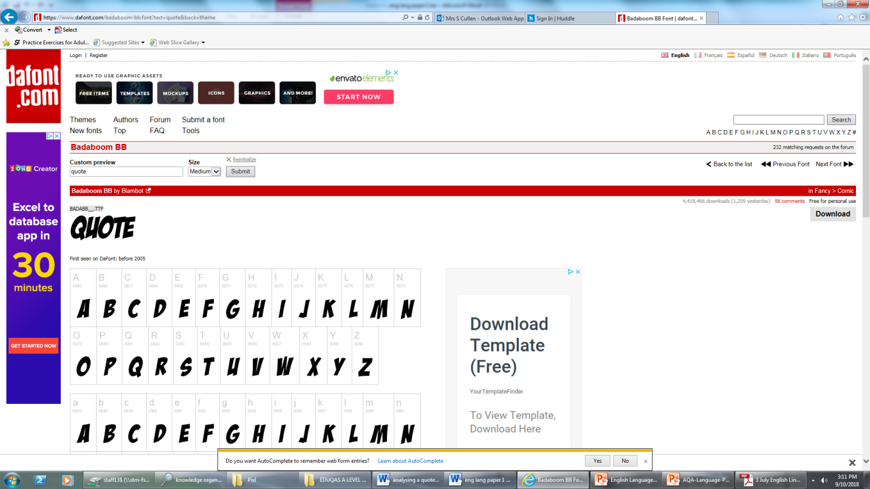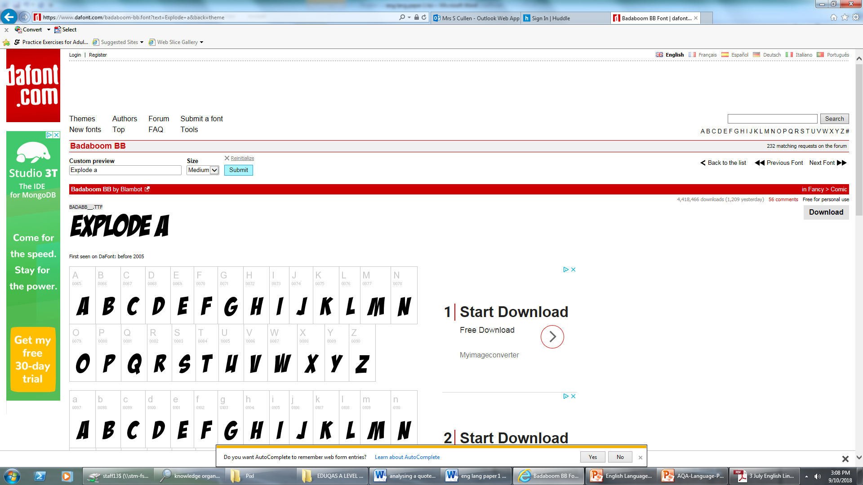

Question 2: How does the writer’s use of language…

**Top Tips **

- Here, you are looking at what the author has done to create meaning. This means you should be looking at

Word choices used by the author (their meaning and connotations)

Techniques used by the author and their effect

- Punctuation and sentence structures and how they create effect

- This means you have to use quotations

- You will be looking for information that is suggested, not obviously said.

- You must look at breaking down meaning in a quotation, then explain how it links to the focus of the question.

SEE THE BACK OF THE SHEET FOR MORE DETAILED TIPS ON HOW TO ANALYSE

Question 3: How does the writer use structure…

**Top Tips** 

Structural features you could talk about:

* How the writer starts and ends the text. Is there a link? Why?
* The order that things are revealed to the reader. Why has this been done?
* How paragraphs are organised and linked/ordered.
* Stream of consciousness
* Foreshadowing
* Flashbacks/memories
* Paragraph organisation
* Where the extract comes from in the text (usually explained in the introduction before the extract).
* Time frame
* Juxtaposition of ideas
* Hooks and withheld information
* Links between opening and closing paragraphs
* Single sentence paragraphs
* Repetition and other recurring patterns
* Narrative perspective

**Some useful sentence starters:**

At the beginning of the text…

We are introduced to the idea of…

The use of … foreshadows…

The use of the single sentence paragraph conveys the idea that…

This links to the ending/beginning of the text because…

The linear/chronological structure of the extract shows…

The development of character is shown

The mood clearly changes on line…

The repeated use of… builds a sense of…

By changing narrative perspective…

AO4

Question 4: To what extent do you agree? **Top Tips **

Here, you will be given a statement about a text. And you have to explain whether you agree or disagree with it. Your answer must:

* Give reasons for your answers
* Comment on the effects achieved by an author that have helped you to come up with your opinion
* Support your comments with relevant quotations from a text.
* Comment on the overall effects that are created by the author
* You must refer to whether you think the extract is successful/effective or not and give reasons why.
* You need PEE, but part of your explanation must include language analysis, and it must say a phrase similar to this: ‘this successfully helps us to understand the characters ***because***…’ If you don’t use the word because, you are not explaining something.

Possible reasons writing might be engaging/effective/interesting:

* Detailed descriptions (makes us feel like we are there, puts us in the setting, experiencing what the characters are experiencing).
* Effective use of vocabulary (carefully chosen words that clearly suggest ideas).
* Effective use of techniques to include the reader (e.g. simile or metaphor to help us see a clear image in our minds, onomatopoeia to help us be part of the setting, rhetorical questions to make us think of the answer, etc).
* Sentence structures that create pace or tension
* Clear understanding of the mood/atmosphere
* Clear understanding of characters, their mood, their behaviour and relationships with others
* Empathy for characters
* Sympathy for characters

AO2

AO2

AO1

Question 1: List four thing…

**Top Tips **

* Will ask you to read an extract and find four bits of information showing something.
* Worth 4 marks, so you have to find 4 separate points
* You can list the things, use quotations or put quotes in your own words.
* No long explanations needed.