Welcome to Psychology

Part of the Social Science Department at King Edward VI Lichfield School

The purpose of this pack is to prepare you for your studies in September by getting you more familiar with the subject of Psychology, which should help you in making the transition from GCSE to A Level. Psychology is a subject that investigates the human mind and behaviour. It is a subject that requires a broad range of skills from scientific investigation, critical evaluation, debating and statistical analysis of data. These activities are designed to show you various aspect of Psychology to prepare you for A Level study.

This document aims to provide you with:

- basic information about the course
- guidance on how you can prepare for a successful start to your A Level course

We follow the AQA Specification which you can view here.

The course at a glance
As you can see from the diagram below, there are three exam papers (each 2 hours long) that are all taken in the summer of Year 13. There are eleven topics studied and examined in Psychology, which should show you the variety that is in the study of Psychology.

A Level Psychology (7182)
Paper 1  INTRODUCTORY TOPICS IN PSYCHOLOGY | Paper 2  PSYCHOLOGY IN CONTEXT | Paper 3  ISSUES AND OPTIONS IN PSYCHOLOGY
Topics:  - Social Influence  - Memory  - Attachment  - Psychopathology | Topics:  - Approaches in Psychology  - Biopsychology  - Research Methods | Topics:  - Issues & Debates in Psychology  - Relationships  - Schizophrenia  - Forensic Psychology
Assessed:  - written exam: 2 hours  - 96 marks in total  - 33.3% of A Level  Exams include; multiple choice, short answer and extended writing questions. | Assessed:  - written exam: 2 hours  - 96 marks in total  - 33.3% of A Level  Exams include; multiple choice, short answer and extended writing questions. | Assessed:  - written exam: 2 hours  - 96 marks in total  - 33.3% of A Level  Exams include; multiple choice, short answer and extended writing questions.

What will I be studying in Year 12?
In year 12 you will be studying:

Research methods:  - Experimental methods  - Observational techniques  - Self-report techniques  - Correlational analysis  - Content analysis  - Case studies  - Ethics of research  - Data Handling | Psychological approaches:  - Origins of psychology  - Learning approaches: Behaviourism  - Learning approaches: Social Learning Theory  - The cognitive approach and the emergence of cognitive neuroscience  - The biological approach  - The psychodynamic approach  - Humanistic psychology
Attachment:  - Caregiver-infant interactions in humans  - Animal studies of attachment: Lorenz and Harlow  - Explanations of attachment  - Ainsworth’s ‘Strange Situation’ and types of attachment  - Cultural variations in attachment  - Maternal deprivation  - Effects of early attachment on relationships | Memory:  - The Multi-Store Model  - The Working Memory Model  - Long-term memory  - Forgetting  - Factors affecting accuracy of eye witness testimony  - Improving eye witness testimony and the cognitive interview
Social influence:  - Types of conformity  - Explanations of conformity  - Conformity to social roles and Zimbardo  - Situational explanations for obedience and Milgram  - Dispositional explanations  - Explanations of resistance to social influence  - Minority influence  - Social influence processes in social change | Psychopathology:  - Definitions of abnormality  - The characteristics of phobias, depression and OCD  - The behavioural approach to explaining and treating phobias  - The cognitive approach to explaining and treating depression  - The biological approach to explaining and treating OCD

What will I be studying in Year 13?
In year 13 you will be studying more research methods, biopsychology and issues and debates in psychology. You will also study 3 topics that are from a list of 9 available topics. At King Edwards we study Relationships, Schizophrenia and Forensic Psychology.

- Issues and debates in psychology  - Research methods continued…  - Biopsychology | - Relationships  - Schizophrenia  - Forensic psychology

For the details of these topics, see the AQA specification linked on the first page.

Background reading
Reading is hugely important when studying Psychology, as it not only develops your understanding of the human mind and behaviour; it also develops your understanding of key concepts and your written skills. Any reading is therefore beneficial, but the following books are of particular use. Read what you can and think about what they suggest about the human mind and behaviour.
- How are the characters similar and/or different to other people?
- Do the characters respond/behave/think the way you would?

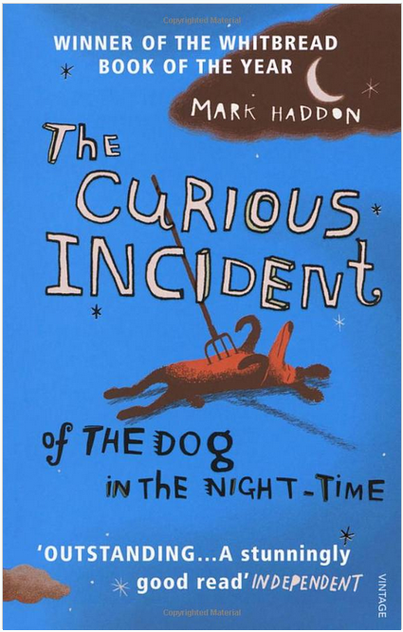 |  | 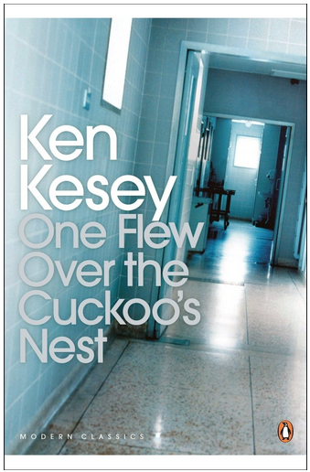
“The curious incident of the dog in the night-time”  by Mark Haddon | “Nineteen eighty-four”  by George Orwell | “One flew over the cuckoo’s nest”  by Ken Kesey | “The outsider”  by Albert Camus
“The perks of being a wallflower”  by Stephen Chbosky | “Trainspotting”  by Irvine Welsh | “Gang leader for a day”  by Sudhir Venkatesh | “In the place of justice”  by Wilbert Rideau

You could summarise what you have learned from your reading. Focus on human behaviour and the ways the human mind processes information.

Title:
- What behaviour was interesting?
- Why was it interesting?
- What caused their behaviour?
- How is their behaviour similar to ‘normal’ behaviour?
- How is their behaviour different to ‘normal’ behaviour?
- Do the characters process information in the way(s) you would?

Background viewing
There are many films and programmes that are useful in helping you develop an understanding of psychology, as the study of psychology is to develop an understanding of the human mind and behaviour.

Films
Watch as many of the following as you have time to. Think about what they tell you about human behaviour and how the mind works. All of the suggested films are rated 12 or 15, but Hotel Rwanda is about the 1994 genocide in Rwanda, so some people may find the content distressing.

 |  |  | 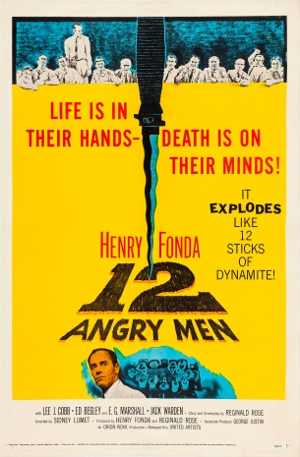
The Stanford Prison Experiment  Trailer | The King’s Speech  Trailer | Rain Man  Trailer | 12 Angry Men  Trailer
Concussion  Trailer | The Shawshank Redemption  Trailer | The Breakfast Club  Trailer | Hotel Rwanda  Trailer

Documentaries & Talks
Watch as many of the following documentaries and talks as you have time to. What have you learned about human behaviour, the mind and the differences and similarities between people?
- The psychology of evil | Philip Zimbardo
- How reliable is your memory? | Elizabeth Loftus
- Exploring the mind of a killer | Jim Fallon
- I Am Not A Monster: Schizophrenia | Cecilia McGough
- The Man Who Loved The Number 12
- The Man With The Seven Second Memory
- I Think We’re Alone Now
- Tourettes: I Swear I Can’t Help It
- Wild Child The Story Of Feral Children

Psychological research
Psychological knowledge is developed and tested through Psychological research. As part of A Level Psychology you will be studying many influential pieces of research.

“Psychology is the scientific study of the human mind and behaviour.”

Psychology is about more than just “thinking about” why we behave the ways we do. We have to conduct research to back up our claims and find evidence to support it. Below are summaries of 5 famous psychological research studies and a series of questions for you to answer after each. If you are interested or want further information, there are great YouTube videos of these studies you can watch.

Milgram (1963)

Aim: to investigate if American citizens would be obedient even if it meant harming others, or if Germans in World War II were just ‘evil’.

Method: a laboratory experiment

Sample: 40 American males between 20 and 50 years of age from the New Haven area, Connecticut.

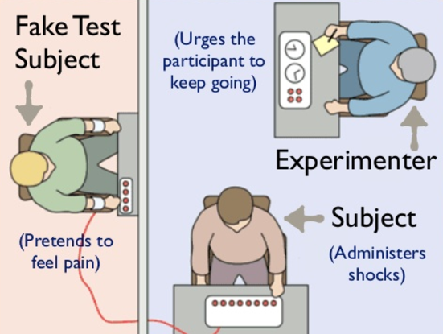
Procedure: Participants were told they were taking part in a learning & memory experiment. They took the role of ‘teacher’, giving what they thought were painful shocks to an actor who they believed was a fellow participant. In truth, there were no shocks. The fake shocks increased from 15 volts (a bit of a painful shock) up to 450 volts (which would kill you).

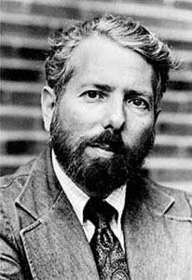
Findings: 65% of the participants delivered what they believed were 450V shocks (a lethal shock) to another person simply because they were told to do so whenever the actor/participant pretended to get an answer wrong. 100% of the participants delivered at least 300V shocks (also lethal) to another person.

Conclusions: Americans are no less ‘evil’ than Germans and that humans obey authority, even if it may cause harm to other humans.

For more details see:
https://www.youtube.com/watch?v=rdrKCilEhC0
Questions:
- Do you think this is a good study? Are the findings useful? Why/why not?

- Are the findings convincing?

- Is the sample sufficient for the study or is it small/biased?
Piliavin, Rodin & Piliavin (1969)

Aim: to investigate if people will help out someone who is suffering on a train, depending on their ethnicity, age, how many people are around and if the suffering person is drunk/old.

Method: a field experiment

Sample: around 4500 passengers on the New York subway.

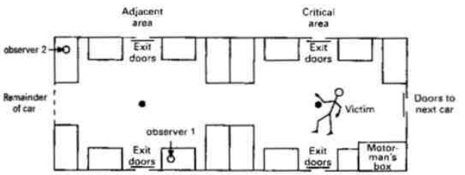
Procedure: Experimenters got an actor to fake collapsing on the New York subway train, and the number of people who helped and the time taken to help were recorded by secret (covert) observers. The ethnicity of the participants was also recorded. They changed the actor, so they could alter the ethnicity and gender and also whether or not they were pretending to be ill and collapsed or drunk and relaxed.

Findings: 79% of victims (who were actors) received help from participants, but this number fell to 50% for the “drunk” victim. There was an ethnicity effect: black people were more likely to help black victims and white people were more likely to help white victims. The more people that were present in the train, the more likely it was that the passenger would receive help.

Conclusions: Ill people are more likely to receive help than drunk ones, women are unlikely to intervene and help out men, there is an ethnicity effect in helping behaviour, and the more people are present the more likely people are to help. This study showed an example of helping behaviour in a real setting.

For more information:
https://www.tutor2u.net/psychology/reference/piliavin-1969
Questions:
- Why might it be a good thing that this study was conducted in a real subway, instead of a lab like Milgram’s research?

- Is the sample of this study good?

- Why is it helpful/useful to know the conclusions this study found?
Loftus & Palmer (1974)

Aim: to investigate if leading questions can actually change people’s memories of an event they witnessed.

Method: laboratory experiment

Sample: 195 students at American universities

Procedure:
In study one, 45 students watched films of car crashes. They were then asked to estimate the car’s speed in response to a question. In the question, the verb used changed. The question was: “about how far were the cars going when the cars hit each other?” but the word hit could be changed to smashed, contacted, bumped or collided.

In study two, 150 students went through the same process but later were asked if they had seen any broken glass at the scene (but there was no broken glass).

Findings:
In study one, the ‘contacted’ condition led people to estimate the car was going at around 32mph but in the ‘smashed’ condition they estimated it was going at around 41mph.

In study two, people who had the ‘smashed’ condition were more than twice as likely to report seeing broken glass at the scene, even though there was none.

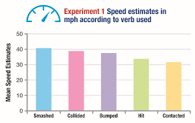
Conclusion: the findings suggest that the way questions are worded can either change the memories of the participants or they indicate to participants that they should remember them in a certain way.
Questions:
- Why would this be useful for police interviewers? How might they change their questions?

- What is the problem with the fact that the car crashes were seen on videos? However – why did they HAVE to be videos and not real life?

- What are some of the ethical issues with the way the study was conducted?

Bandura, Ross & Ross (1961)

Aim: to investigate the extent to which children will repeat aggression that they’ve observed an adult doing on a doll.

Method: laboratory experiment

Sample: 72 children (36 boys and 36 girls)

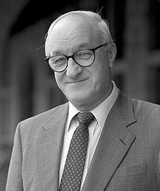
Procedure: One group of children saw an adult attack an inflatable doll (called a Bobo doll) in a play room. Another group of children saw the adult behave in a friendly way with the doll. All the children were then deliberately frustrated (by being taken to a room with toys but not being allowed to play with them) and then were left in the room with the Bobo doll and observed.

Findings: Children who watched the aggressive adult also repeated highly aggressive behaviour. The children who had not seen the aggressive adult however were not aggressive with the Bobo doll. Boys were more likely to imitate an aggressive man and girls were more likely to imitate an aggressive woman. Some children even used hammers and fake guns on the doll, if they had seen the adults doing the same. If they had not observed an adult doing this, they would not do this.

Conclusions: Children are highly likely to imitate adult violence when given the opportunity to do so.
Questions:
- What does this study suggest about serious cases like the case of Jamie Bulger?

- What are the implications of this for letting children watch violent/horror movies and playing violent/horror video games?

- Is this a good study? What are some of the issues with the study?

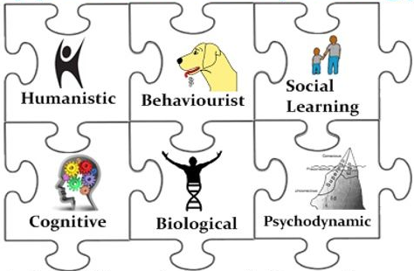
Psychological approaches
Psychology doesn’t have one way of explaining human behaviour; there are competing collections of theories, known as psychological approaches. You need to know about six key psychological approaches for your A level – they are different ways of explaining human behaviours.

Some of these are listed below: your job is to do some research on them using the internet (Try Simply Psychology and Tutor2u and there are also plenty of great videos on YouTube you can watch). You should find out: How might each approach explain human behaviour? What are the key ideas and concepts?
- Behaviourist Approach
- Social Learning Theory
- Cognitive Approach
- Biological Approach
- Psychodynamic Approach
- Humanistic Approach

What are the lessons like?
You will be expected to be engaged in your own learning and be willing to work hard to develop your understanding of Psychology. Lessons include discussions, Q&A, analysis of videos, written work, discussion and evaluation of psychological research. You will also work on developing your skills, e.g. mathematical skills and how to write a long answer question in Psychology. A Level Psychology is not just about learning to pass exams; we want you to develop a depth of understanding of Psychology as a whole.

What books will I need?
We study the AQA A Level Psychology and we will use a number of resources to study the required topics. The main textbooks used are ‘AQA Psychology for A Level, both Year 1 and Year 2’ (see below). These books are the 2nd edition and are available soon. We will make these books available for purchase through parent pay in the autumn term. We have copies of the first edition available for use in lessons. There are links below to see sample pages.
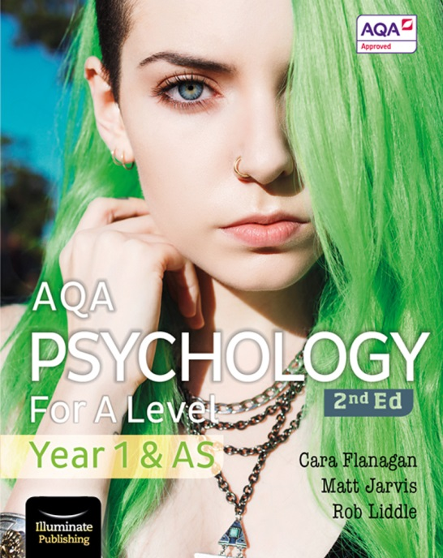 | 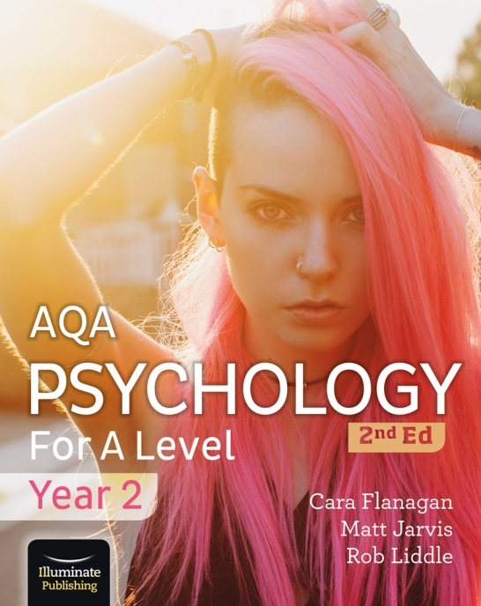

Sample pages of the books are linked below:
https://www.illuminatepublishing.com/samples/AQA_Psychology_for_A_Level_Y1_AS_SB/
https://www.illuminatepublishing.com/samples/AQA_Psychology_For_A_Level_Year_2_Sample/

Who will be teaching me?
You will be taught by Mrs Cottier-Cooper (Head of Social Science) and either Miss Socratous (Lead Teacher for H&SC) or Mrs Forster (Deputy Head Teacher). As with all A Level subjects you will be taught Psychology for 9 hours per fortnight and you will be taught by Mrs Cottier-Cooper for 5 of those hours. As you have seen there are 11 topics and you will cover 6 of those topics in year 12.

Your task is to help you gain an understanding of what Psychology is really all about. Use the internet (e.g. websites like https://www.tutor2u.net/psychology/blog/psychology-6-key-terms-glossary-notes, but you can also use YouTube and other sources) to research and understand what the following key terms mean and create a short definition for each in your own words.

The most important thing in an A level is your understanding – so it’s not about having the “right” or “word-perfect” definition, it’s about you understanding what a concept means

Term | Explanation
Experiment
Observation
Self-report
Correlation
Ethical issues
Behaviourist psychology
Social learning theory
Cognitive psychology
Biological psychology
Psychodynamic psychology
Humanistic psychology
Phobia
Depression
OCD
Schizophrenia
Validity
Reliability
Nature-Nurture debate
Free Will – Determinism debate

If you would like any additional information about the course, then please e-mail:
jcottier-cooper@kingedwardvi-lichfield.staffs.sch.uk
We hope you enjoy the activities and we look forward to meeting you in September.

