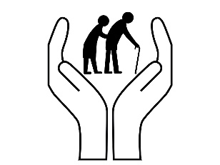
Welcome to the
Health and Social Care department
Part of the Social Science Faculty at King Edward VI Lichfield School

This document is designed to start to prepare you for the transition from GCSE to Level 3 study.

This document aims to provide you with:
- Basic information about the course
- How you can prepare for a successful start to your Level 3 HSC course

We follow the Pearson Level 3 BTEC Specification which you can view here.

What will I be studying?
This course allows you an insight in the many roles available within health and social care from nurses to social workers to child care assistants and beyond they have many key features that we shall explore and apply. You will be studying a range of units which will help you to gain skills that will be valuable in your chosen profession or future study. You will learn about the human body and mind alongside the changes across time. You will learn what it means to work in the sector and what skills and behaviours you will need to develop. We will study the following units; although the final one is subject to change and you may not study them in this order.

During unit one, Human Lifespan Development, you will focus on:
- Understand the different influences on an individual’s development and how this relates to their care needs.
- You will be introduced to the biological, psychological and sociological theories associated with human lifespan development.
- You will explore the physical effects of ageing and the theories that help to explain psychological changes.
- How you will be assessed: this is a paper based exam, that lasts for 1 hour 30 minutes, that is worth 90 marks. There is a variety of short- and long- answers. The questions are designed to test your knowledge on individual’s development, the factors that affect this and the theories that explain this.

During unit two, Working in Health and Social Care, you will focus on:
- You will be introduced to the roles and responsibilities of health and social care practitioners and the organisations they work for.
- You will see how a wide range of roles, including doctors, nurses, physiotherapists, occupational therapists, social workers, youth workers, care workers and other professionals, work together to ensure that the individual needs of vulnerable people are met.
- How you will be assessed: this is a paper based exam, that lasts for 1 hour 30 minutes and worth 80 marks. There will be four sections and include short- and long- answers. The questions are intended to assess your understanding of how health and care services who need professional support. Each section will relate to a different service user group, for example the frail elderly, people with learning disabilities, people with mental health problems or people with long-term illnesses.

During unit five, Meeting Individual Care and Support Needs, you will focus on:
- You apply knowledge in order to provide the care and support that meets the needs of an individual in a health and social care environment, for this you need to understand the principles and practicalities that are the foundation of all the care disciplines.
- You will need to consider ethical issues that may arise and challenges the individual may face in order to provide personalised care.
- You will reflect on the different methods used by professionals working together in a multi-agency team to provide a package of care and support that meets individual needs.
- How you will assessed: by a series of assignments set at school. You will provide practice assignments to help you prepare for the final assessment. You will need to check that your work first meets all the pass criteria before moving on to merit and then finally distinction criteria.

The final unit will also be a series of assignments based on in class work exploring a specific aspect of health e.g. physiological or psychological care. You will need to look at case studies as you did in unit five and use your knowledge to explain their behaviour or condition leading to treatment plans.

Health and Social Care in the Media
It is important to make the public realise about the issues which are prevailing in society relating to health and social care. One way in which public awareness is raised about health and social care in general and issues that exist within the health and social care sector is through the media.
Your task is to write an essay with the following title: ‘Discuss the portrayal of Health and Social Care within the media’
You must watch/read the some of the examples above (perhaps 3 or 4) to help with your essay. Consider the following:
- What issues, if any, are being raised in the stimulus?
- How does the stimulus present H&SC?
- Is the stimulus informative/helpful and why?
- Are there any quotes/scenes etc that stand out to you and why?
- How effective is the stimulus in raising public awareness about H&SC/Issues?

This list is NOT exhaustive there may be other questions/ideas you wish to consider as you watch or read.

Learning Log
Record here any additional reading/viewing you are undertaking in order to show what you have been completing in order to prepare you for the course. Use the reading list on the previous slides you have been given for guidance on what you could you watch or read.

Date | Title | Summary of content | My thoughts

Task: Research and define the following words which are central to Unit 1: Human Lifespan Development. Then, draw a symbol to summarise the term and help you remember it.
Term | Definition | Symbol
Adolescence | An important status change following the onset of puberty during which a young person develops from a child into a adult.
Advocate
Attachment
Development
Discrimination
Diversity
Empathy
Ethical
Fine Motor Skills
Growth
Holistic Approach
Milestone
Nature
Nurture
Safeguarding
Self-Concept
Self-Esteem

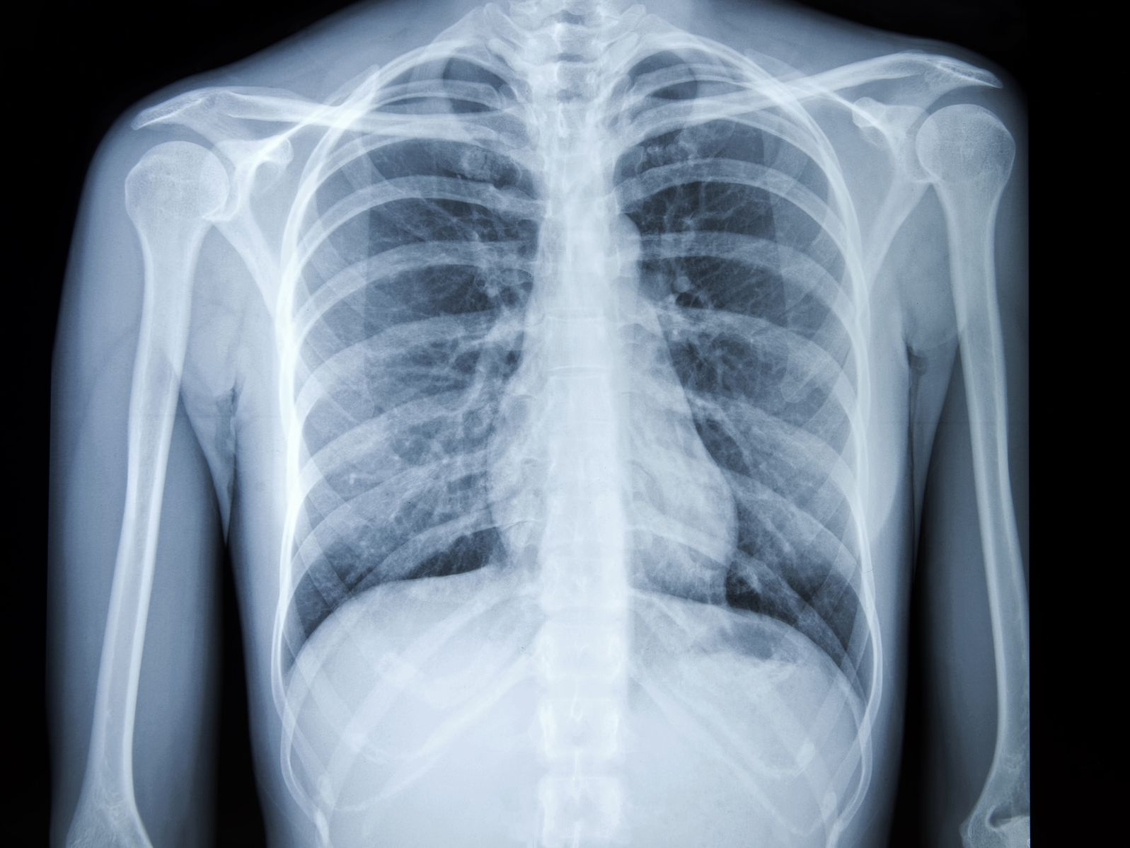
Research a list of Health and Social Care jobs/ medical terms for each letter of the alphabet

N
O
P
Q
R
S
T
U
V
W
X
Y
Z

A
B
C
D
E
F
G
H
I
J
K
L
M

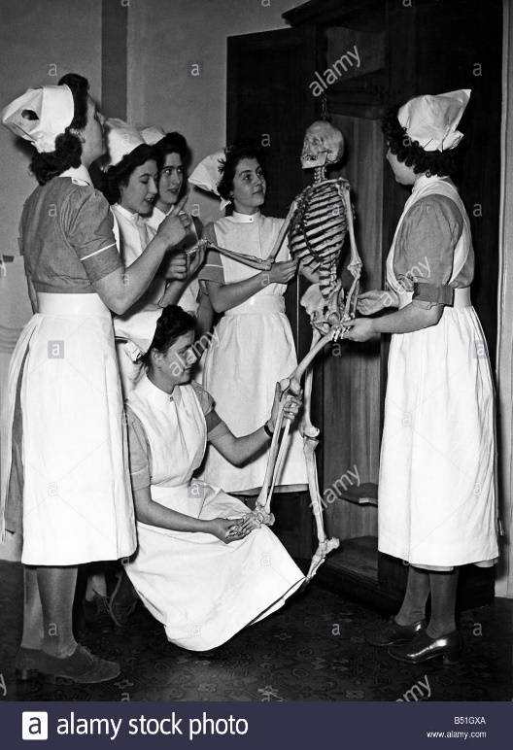
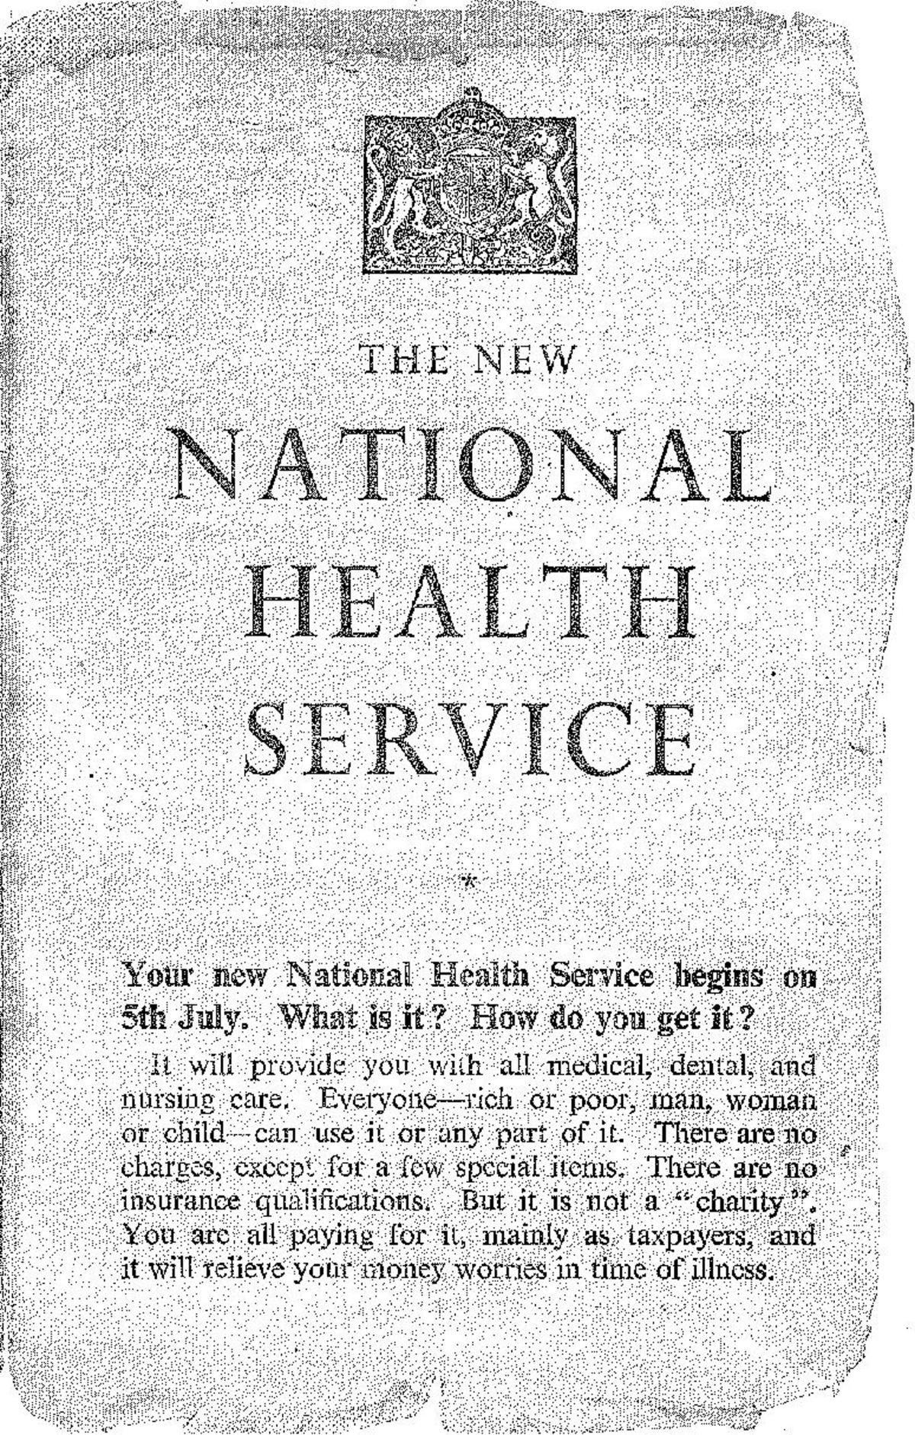
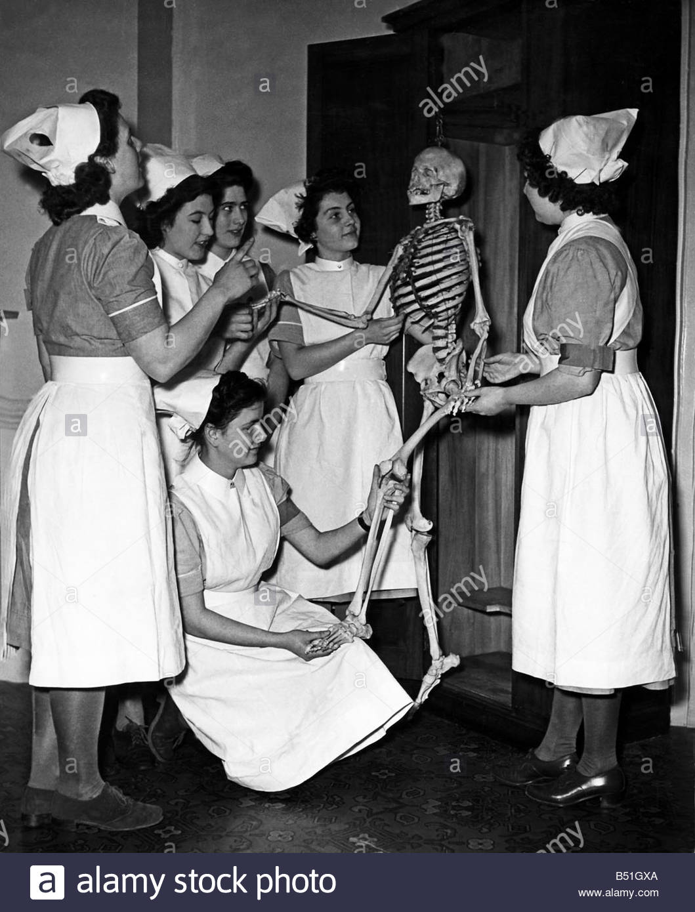
History of the NHS

Make a leaflet outlining the history of the NHS
Include sections on:
- Healthcare before the NHS
- When/ why the NHS was produced
- What the NHS does
- Significance of the NHS
- How is the NHS different in other countries

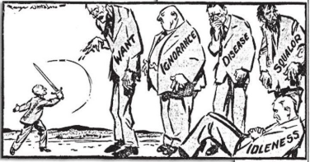
The Beveridge Report, 1942
In 1942, a plan had been presented by William Beveridge, a senior civil servant, detailing key areas for post-war reconstruction, aimed at establishing a national system of welfare for the people. It identified ‘five giants’ that were to be overcome: want, disease, ignorance, squalor and idleness.
When the Beveridge Report first appeared, it was welcomed by all the parties. There was broad agreement that protection needed to be provided for all members of society, and so when Labour came to power in 1945, they implemented the proposals in this report, thereby establishing the welfare state, a system which all governments after 1951 accepted in its essentials. This common acceptance became known as consensus.
Giant | The 1945 Labour Government’s Solution
Want | To be ended by National Insurance. The National Insurance Act created a system whereby the government, employers and employees all paid for insurance which would pay out in the event of unemployment, sickness, maternity and retirement.
Disease | To be ended by a comprehensive health service. The National Heath Service Act provided free medical and hospital treatment for all (the NHS).
Ignorance | To be ended by an effective education system. The Labour Party continued to support the Conservative’s 1944 Butler Education Act which provided free education within grammar schools, technical schools or secondary schools.
Squalor | To be ended by slum clearance and rehousing
Idleness | To be ended by full employment
The idealism that inspired the government’s welfare programme came at a heavy financial cost, which added to the financial burdens it inherited in 1945.
Research task
Chose a professional from the following:
- Midwife
- Paramedic
- Paediatric nurse
- Nutritionist
- Physiotherapist
You could choose your own idea from health and social care roles if you prefer. Create a fact file for your chosen job role. You could include:
- A day in the life of……
- General roles and responsibilities
- Routes into the role/ qualifications required
- Skills & qualities
- Average pay
- Where they work
- Who they work with
And anything else you think may be suitable!

A palliative care nurse will get involved with everyone who gets coronavirus.
True or False?
Colour code the statements in order to show if they are true or false.
True False
Adult social workers support people with poor mental health.
A district nurse will only work with the elderly.

Domiciliary carers provide care in the home.

Auxiliary nurses help support other nurses to do their roles.
Only phlebotomists are allowed to take blood.

On ‘The front line’…….
What does it mean when people talk about being ‘on the front line’?
_______________________________________________________________________________________________________________________________________________________________________________________________________________

Government declares a ‘pandemic’…….
What does it mean when people talk about the situation as a pandemic?

__________________________________________________________________________________________________________________________________________________________________________________________________________________

Optional Extension Task: Health and Social Care in a Pandemic
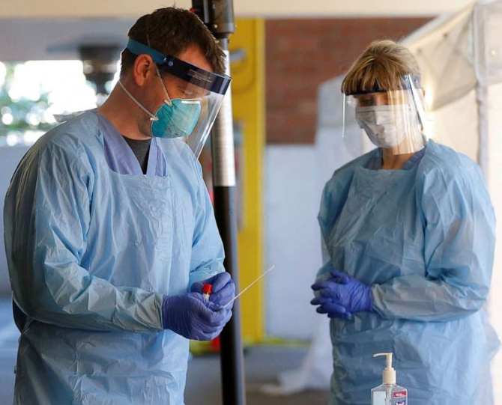
At the moment, we are living through a time when health and social care services are needed more than ever! Those who have chosen this as a profession have stepped up to look after those affected by the COVID-19 pandemic. You will be seeing on the news constant stories about the amazing work that is going on in the British NHS and Care system and this task is your opportunity to find out more about pandemic control in the area and also the work of the World Health Organisation (WHO) in organising a global response. This will require you to research and understand why the steps have been taken around us and how this fits into the global picture.
As this is an extension task you can complete as much of this as you like or are able to but this level of thinking and also detail will help build the skill required for distinction or distinction* in your level 3 course.

Task 1 – What is the role of health promoters?
You will need to read through the following information and complete some research in order to explain the roles of the following organisations in maintaining the health of the population:
World Health Organisation (WHO).
Department of Health
Public Health Agency
Clinical Commissioning Groups (CCGs)
Health professionals

The role of Health Promoters
Aims
Health promoters aim to improve the health of individuals and the population and reduce health inequalities globally, nationally and locally.
Global health promotion
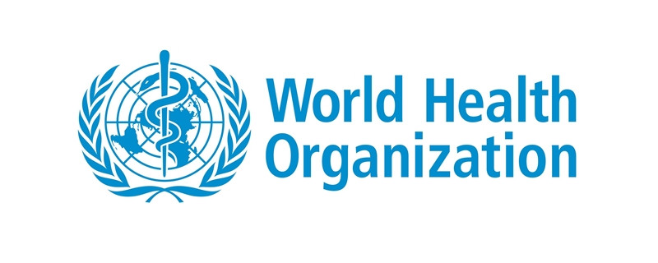
The World Health Organization, within the United Nations promotes and protects good health worldwide, by providing information about disease outbreaks, co-ordinating crisis intervention and the response to humanitarian emergencies; establishing International Health Regulations and an international system of classifying diseases.
National, regional and local health structures in England include the
- Department of Health
- Public Health Agency
- Clinical Commissioning Groups (CCGs)
- Health professionals
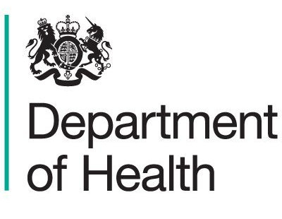
In England, the Department of Health (DH) leads, shapes and funds health and care while Public Health England protects and improves the nation’s health and well-being, and reduces health inequalities. Local authorities are responsible for public health and do this through health and well-being boards which include representatives for all CCGs in the area, among others. Health and well-being boards assess the needs of their local community through Joint Strategic Needs Assessments (JSNAs) then agree priorities in Joint Health and Well-Being Strategies (JHWSs). Together JSNAs and JHWSs form the basis of commissioning plans for public health for CCGs.
Task 2: Why do you think is necessary for local authorities to have control over the needs of the people in their area? For instance, think about the people living in Lichfield and then compare that to the population living in London; do they have the same needs? What would their focus for health be on?
Have a look at Staffordshire CCG, they are having a funding crisis due to the high proportion of elderly residents needing care.

Approaches to promoting public health and well-being
Promoting public health and well-being includes:
- Monitoring the health status of the community and identifying those most at risk, e.g. children, unemployed, older people, minority ethnic groups.
- Health surveillance programmes.
- Targeted education and health awareness and health promotion programmes.
- Socio-economic support to reduce health inequality between individuals and communities, e.g. winter fuel payments, free school meals, housing support.
- Improving access to health and care services.
- Co-ordinating national and local services.
- Disease registration to inform of health trends and for strategic health planning.
- Statutory duty to notify certain communicable diseases e.g. measles, tuberculosis (in this case COVID-19).
Task 3 – Find examples of the British Government and relevant agencies putting these measures into practice; e.g. what have they done for those receiving free school meals? How have they identified those most at risk and supported them?
Task 4: Compare Britain’s response to at least one other country and its response to the pandemic. Assess the strengths and weaknesses in each approach to looking after public health.
Challenge: Look at least 3 news articles from a variety of sources and consider what they say about the British approach to the pandemic. Do you think it could have been improved? Justify your suggestions.

Pandemic Phases
2018 marks the 100th anniversary of one of the largest public health crises in modern history, the 1918 influenza pandemic known colloquially as “Spanish flu.” The intensity and speed with which it struck were almost unimaginable – infecting one-third of the Earth’s population, which at the time was about 500 million people. By the time it subsided in 1920, tens of millions people are thought to have died. By 1952, it was decided that an influenza surveillance system was needed for the “collection, correlation, and distribution of information regarding occurrence, epidemiology and laboratory findings”. This is known as the Global Influenza Surveillance and Response System (GISRS). It was predicted that the next pandemic would most likely be caused by influenza.
This has lead WHO to conduct and watch outbreaks of strains of flu and cold across the world and create detailed reports on the readiness of countries and also to map out the stages of a pandemic and main actions to be taken in order to minimise the impact of this type of event.
Task 5: Below is a link to the WHO pandemic phase descriptions; use these alongside research on the response to the COVID-19 Pandemic in order to complete the table below. https://www.who.int/influenza/resources/documents/pandemic_phase_descriptions_and_actions.pdf
Phase | WHO Suggested Actions | UK Actions | Effectiveness of response | Recommendations for future pandemic planning
1
2
3
4
5
6
Post Peak

