A Welcome to Economics!
Below is a range of resources and activities prospective Yr12 A Level Economics students can use to help prepare your Sixth Form studies.
"The theory of economics does not furnish a body of settled conclusions ... it is a method rather than a doctrine, an apparatus of the mind, a technique of thinking which helps its possessor to draw correct conclusions."
"Practical men, who believe themselves to be quite exempt from any intellectual influences are usually the slaves of some defunct economist."
John Maynard Keynes
Both of the above quotes by John Maynard Keyes (the founder of macroeconomics) highlight the power that economic thought has on our lives and how studying economics not only develops our understanding of the subject of economics itself but how it empowers us with a logical way of approaching problems and the conclusions we arrive at.
For students who are just starting on their A Level Economics course, these notes are designed to provide brief background information and advice on how best to reach your potential in this subject and to get the best from the chance to study a live subject that changes every day.
There are many things that you can do to enhance and deepen your understanding of Economics, either as preparation for studying the subject to a higher level at university, to help you in your future career, or to complement your work in other subjects. However, the first and best piece of advice that can be given to any aspiring economist is to enjoy the subject and see its relevance, and to do this you need to keep your eyes open and be listening all around you as the world of economics is happening every day and everywhere. Therefore as a budding economist you should be watching and listening to the news regularly.

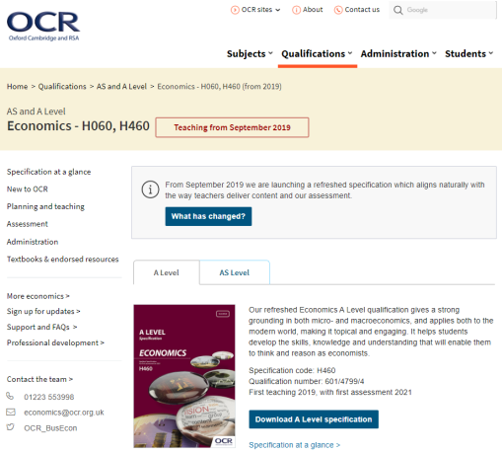
- For a look at the syllabus:
The OCR A Level Economics Specification can be found at:
https://ocr.org.uk/qualifications/as-and-a-level/economics-h060-h460-from-2019/
The examination specification plus past exam papers, mark schemes and examiners reports can be found on the OCR website

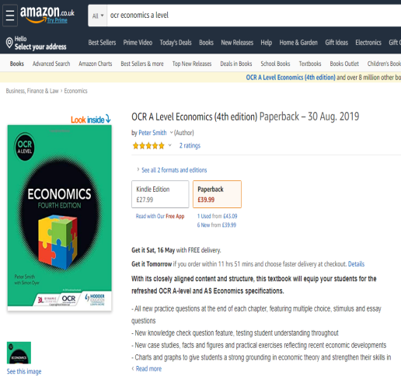
- For a look at the textbook:
The recommended textbook is “OCR A Level Economics (4th edition)” by Peter Smith with Simon Dyer
www.amazon.co.uk/OCR-Level-Economics-Peter-Smith/dp/1510458409/ref=sr_1_1?keywords=ocr+economics+a+level&qid=1585219921&sr=8-1
The textbook has been prepared for the OCR A Level Business course this can be bought from e-tailers like Amazon (see link above) or directly from the Business department (we have a small stock of new textbooks that we bought in bulk at the beginning of the year).
- Online Resources
Few subjects are suited more to the opportunities provided by the internet than Economics. There is a wealth of useful (and not so useful) information, comment and analysis out there for you to dip into, but given the range and quality of internet based resources it is often good to know a few sites that will be helpful. These include:
Recommended websites / follow on Twitter / Apps on your mobile include:
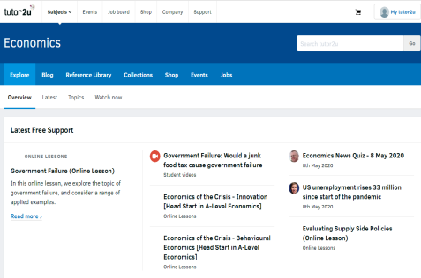
The Tutor2u website
www.tutor2u.net/business
The Tutor2u is one of the UK’s leading portal sites for Economics, Business and Politics and is particularly suitable for students studying A levels. You will find a comprehensive collection of free study notes, presentations and quizzes. I also recommend that you use the popular discussion boards.

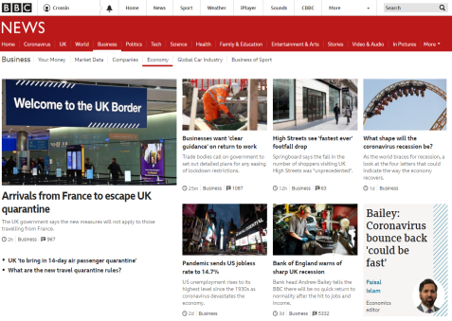
The BBC website
www.bbc.co.uk/news/business
We are fortunate of have one of the best (if not THE best) news reporting media companies in the world based in the UK. So whether you are looking to catch up with the latest economic story in the news or want to use its “Global economy” page to get to grips with the latest views of what is happening in the world economy the BBC news website is always a great starting point.

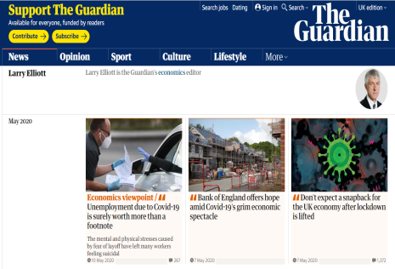
The Guardian
www.theguardian.com/business/economics
If you prefer to get your daily “broadsheet” newspaper in electronic (rather than paper) form then one of the best - and one that is still completely free – is the Guardian. Not only does it provide up to date news as well as having some very good economic editorials/comment pages – but the articles by Larry Elliott the Economics editor are usually pitched at exactly the right level for students of economics.
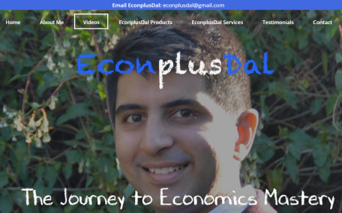
EconplusDal
www.econplusdal.com
A series of youtube videos delivered by a teacher of economics (who teaches the OCR specification) that can help support learning and revision.

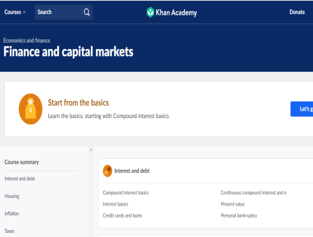
Khan Academy
www.khanacademy.org
Khan Academy is a new type of online resource (but one that may well be the future of education). This not-for-profit organisation looks to produce a wide range of teaching videos that individuals can follow at their own pace. Excellent for model based theory (which underpins so much of economics) and with lots of macro and micro videos to access, these can be used to both consolidate classroom learning and help develop a deeper understanding of a particular issue.
- Other recommended reads
Quality newspapers / magazines such as: the Times, Guardian, Telegraph, Independent, journals such as The Economist (NB. there are reduced rates for students on some of these, for example, students were able to buy The Economist for 6p per copy instead of the standard £2!), and the Economic Review magazine (available in the KES Learning Resources Centre or you can subscribe for your own student copy)
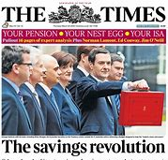  www.thetimes.co.uk | 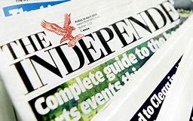  www.theguardian.com/uk/business | 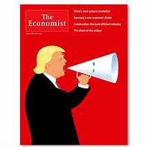  www.economist.com | 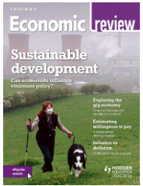  www.hoddereducation.co.uk/economicreview#!

- Get Reading
Economic Books that you might enjoy reading include:
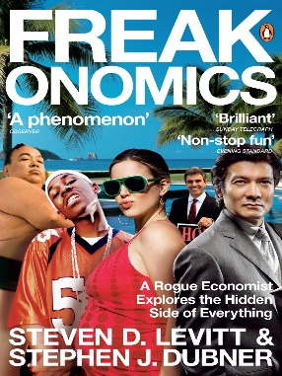  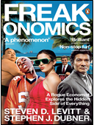 | - Freakonomics (Steven Levitt & Stephen Dubner)  A cult bestseller, Freakonomics looks to show how an economic approach can help us understand teh decision making that is at the heart of everything we see and do: from parenting to crime, sport to politics, fat to cheating, fear to traffic jams. Asking provocative and profound questions about human motivation Freakonomics is a collection of articles written by Levitt, an expert who had gained a reputation for applying economic theory to diverse subjects not usually covered by "traditional" economists. (Note: you can also go to the freakonomics website for more upto date examples https://freakonomics.com/)
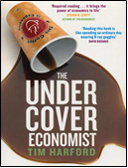 | - The Undercover Economist (Tim Harford)  The book provides an introduction to principles of economics, including demand-supply interactions, market failures, externalities, globalisation, international trade and comparative advantage. It explains in non-technical terms how Starbucks and other coffee providers price their products, why it is hard to buy a decent used car, why the health insurance system in the United States is failing, and why poor countries remain poor while the People's Republic of China has continuously grown rich in the last couple of decades.
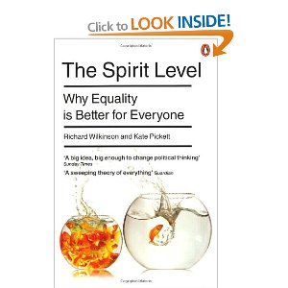  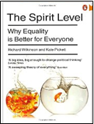 | - The Spirit Level (Robert Wilkinson & Kate Pickett)  A groundbreaking book that looked to use detailed data to support the view that (in developed economies) inequality was bad for everyone and that the drive to increase GDP at all costs would make everyone worse off. Covering a range of economic indicators including: health, imprisonment, obesity, social mobility, trust and community life, violence, teenage pregnancies, and child well-being, it showed that outcomes are significantly worse in more unequal countries.
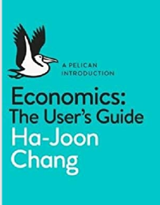 | - Economics: a user’s guide (Ha-Joon Chang)  Ha-Joon Chang (a professor of economics at Cambridge University and column writer for the Guardian) has put together probably the best introductory book to economics. Starting from the question “Why do you need to learn economics?” he takes us though he way that economic theory and policy impacts on all aspects of our lives. A excellent introduction to the subject.
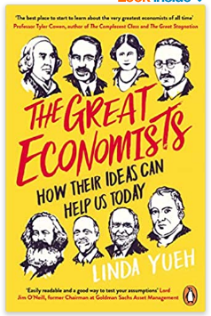 | - The great economists (Linda Yueh)  If you are after an review of the people and ideas that underpin the study of ecomics then this is the book for you. Starting with the “father” of economics Adam Smith, and covering economic “heavy weight” of; Ricardo, Marshall, Marx’s, Keynes, Hayek, Schumpeter and Friedman, this book gives a great insight into the diversity and thinking that underpins modern economic thinking
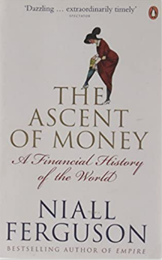 | - The accent of money (Niall Ferguson)  If it is an understanding of money and the money markets want then this is the book for you. Niall Ferguson takes us on a journey from the first coins (600BC) to the bond market, joint-stock company shares, insurance markets through hyper-inflation, exchange rate crises and the (regular) bubbles that these markets have seen (this was also a TV documentary which can be seen here - www.dailymotion.com/video/x5uxhnu)
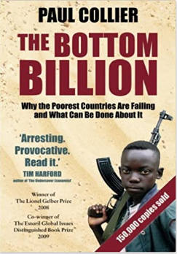 | - The bottom billion (Paul Collier)  This book, by one of the world's leading experts on Africa and poverty - economist Paul Collier - highlights the level of inequality in the world and the particular problems that are faced by the poorest. The “bottom billion" of the world live in countries who appear to be largely immune to the positive forces of the global economy, and as a result are falling farther behind. Collier identifies and explains the four traps that prevent the world's billion poorest people receiving the benefits of globalisation, and argues that if things are to change we need a thorough understanding of the complex and interconnected problems that the world's poorest people face.
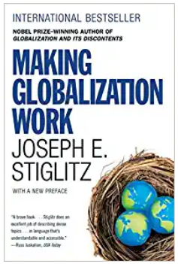 | - Making globalization work (Joseph Stigliz)  Building on the international bestseller Globalization and Its Discontents, Joseph Stiglitz offers an agenda of inventive solutions to our most pressing economic, social, and environmental challenges, with each proposal guided by the fundamental insight that economic globalization continues to outpace both the political structures and the moral sensitivity required to ensure a just and sustainable world. As economic interdependence continues to gather the peoples of the world into a single community, it brings with it the need to think and act globally. This trenchant, intellectually powerful, and inspiring book is an invaluable step in that process.

FILMS
Why not take some time out to what a few films that will help develop your business knowledge and understanding such as:

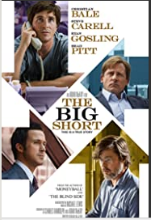 | The Big Short (2015): certificate 15  In 2006-2007 a group of investors bet against the US mortgage market. In their research they discover how flawed and corrupt the market is.  With a host of big names (including: Ryan Gosling, Brad Pitt, Steve Carell and Christian Bale) and some brilliant cameos, this is quite possibly the best ever (and funniest) film based around economics ever made!  Economic reference: 2008 Financial Crisis
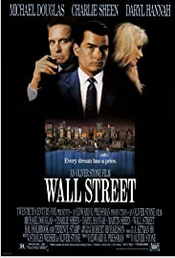 | Wall Street (1987): certificate R  A young and impatient stockbroker is willing to do anything to get to the top, including trading on illegal inside information taken through a ruthless and greedy corporate raider who takes the youth under his wing. This is the movie where the phrase “greed is good” came form!  Economic reference: Stock markets, (Public) Limited Companies, Asymmetric information
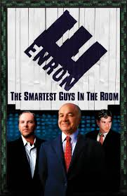 | Enron: The Smartest Guys in the Room (2005): certificate 15  The film examines the 2001 collapse of the Enron Corporation which resulted in criminal trials for several of the company's top executives during the ensuing Enron scandal it also shows the involvement of the Enron traders in the California electricity crisis.  Economics reference: Profit, (Public) Limited Companies, Stock market, Insider Trading
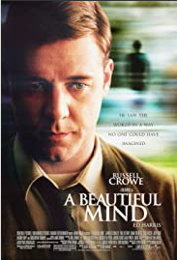 | Beautiful mind (2001): certificate PG13  The film is based in the autobiography of Nobel-Prize-winning economist John Forbes Nash (despite controversy concerning its accuracy with regard to Nash’s life) tells the story of Nash who was an exceptional mathematician and economist, specialising primarily in game theory (hence Nash equilibrium and the Nash embedding theorem). The film shows the story of Nash’s life, his work, research and struggle with schizophrenia.  Economics reference: Behavioural economics, Nash equilibrium, Oligopolies / cooperatives
Activities to develop you economic understanding
Have a go at the following tasks to start developing your economic knowledge

TASK 1: The UK Economy
Research the performance of the UK Economy.
Find out how the UK economy is currently performing against the following Macroeconomic Objectives:
  - Economic growth at 2.0 to 3.0%.
  - Stable low inflation at 2.0% (CPI)
  - Unemployment at 5.0%
  - Rising standards of living

You should find out the latest figures regarding the UK’s performance as measured against their macroeconomic objectives. This will include data on:
- Gross Domestic Product (“GDP”)
- Inflation (Consumer Prices Index “CPI”)
- Unemployment (both number and rate)
- Wage rates and GDP per capita

You might find the https://www.ons.gov.uk/economy website helpful as a starting point.

TASK 2: The Global Economy
Research the economies of a country of your choice or pick one from the list below.
China | India | USA | Japan
Brazil | Germany | Nigeria | Vietnam
You must present your findings in a creative and informative way. The best work will be used for a display.
Your factsheet MUST include the following data for the last 5 years:
- Growth rates of GDP (and which sectors are: largest, growing / declining)
- Average income levels (and levels of poverty both absolute and relative)
- Employment / Unemployment Rates (Which industries are people mostly employed in?)
- Balance of Payments (What do they trade in? Who are their main trading partners?)

You should also comment on factors that have influenced their economic performance over the last 5 years. What are the strengths and weaknesses of their economy (e.g. are they a strong exporter? Do they rely on the service industry or are they good manufacturers?)
TASK 3: Economists & economic theory
Research these Economists and their theories (plus add one of your own!)
Theorist | School of Thought | Economic Theory | Explanation and Impact
- Adam Smith | Classical | Division of Labour
 |  | Invisible Hand
 |  | Economic Growth
- David Ricardo | Classical | Comparative Advantage
- John Maynard Keynes | Keynesian | Paradox of Thrift
 |  | Multiplier Effect
 |  | The role of government
- Friedrich Hayek | Austrian | Business Cycle
 |  | Role of government
- Milton Friedman | Monetarist | Monetarism

Economist of your choice:

