Do you mean Business?
Below is a range of resources and activities prospective Yr12 A Level Business students can use to help prepare your Sixth Form studies.
The world in which we live is dominated by businesses big and small. A Level Business is an exciting and interesting subject which can help you to understand the world in which we live. Businesses are dynamic organisations which reflect the values of society and the people working within them. A study of business will help you to gain an insight into both.
For students who are just starting on their A Level Business course, these notes are designed to provide brief background information and advice on how best to reach your potential in this subject and to get the best from the opportunity to study a live subject that changes every day!
The emphasis is upon you contributing to your own learning by your involvement in lessons and your further reading of the subject in your own time. There are many things that you can do to enhance and deepen your understanding of Business, perhaps as preparation for studying the subject to a higher level at university or to complement your work in other subjects.
However, the first and best piece of advice that can be given to any Business Studies student is to enjoy the subject and see its relevance, and to do this you need to keep your eyes open and be listened all around you as the business world is changing every day and everywhere. Therefore you should be watching and listening to the news regularly.

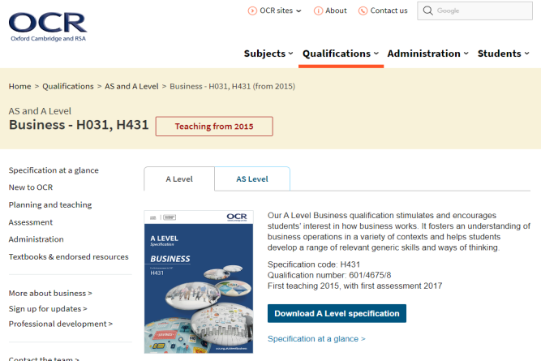
- For a look at the syllabus:
The OCR A Level Business Specification can be found at:
https://ocr.org.uk/qualifications/as-and-a-level/business-h031-h431-from-2015/
The examination specification plus past exam papers, mark schemes and examiners reports can be found on the OCR website

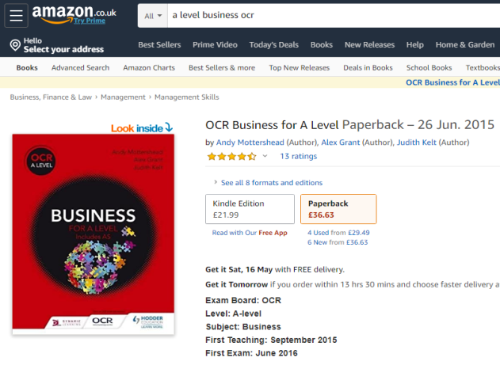
- For a look at the textbook:
The recommended textbook is “OCR Business for A Level” by Andy Mottershead, Alex Grant, Judith Kelt
https://www.amazon.co.uk/OCR-Business-Level-Andy-Mottershead/dp/1471836150/ref=sr_1_1?keywords=a+level+business+ocr&qid=1579777441&sr=8-1
The textbook has been prepared for the OCR A Level Business course this can be bought from e-tailers like Amazon (see link above) or directly from the Business department (we have a small stock of new textbooks that we bought in bulk at the beginning of the year).
- Online Resources
Few subjects are suited more to the opportunities provided by the internet than Business. There is a wealth of useful (and not so useful) information, comment and analysis out there for you to dip into.
Recommended websites / follow on Twitter / Apps on your mobile include:
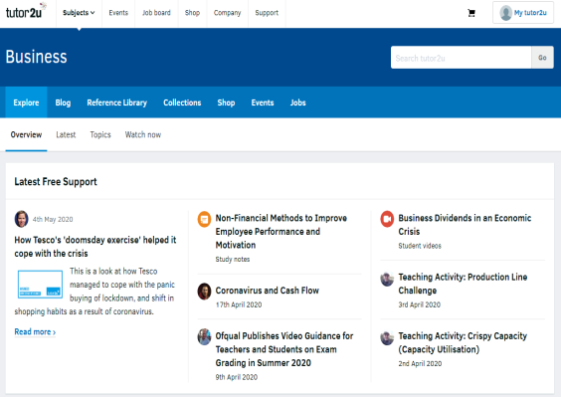
The Tutor2u website
www.tutor2u.net/business
The Tutor2u is one of the UK’s leading portal sites for Business, Economics and Politics and is particularly suitable for students studying A levels. You will find a comprehensive collection of free study notes, presentations and quizzes. I also recommend that you use the popular discussion boards.

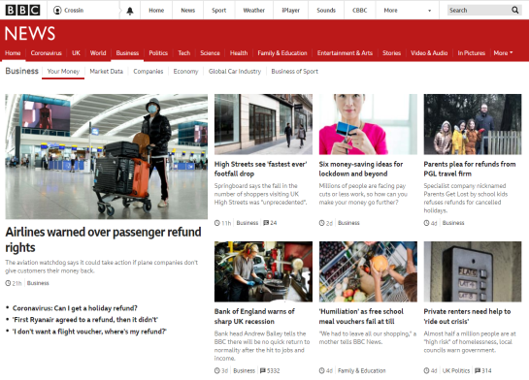
The BBC website
www.bbc.co.uk/news/business
The BBC News website, and in particular its business page, is another excellent resource – with news stories and background articles added every day – plus external links to news sources and relevant organisations. It is a good idea to log into the BBC News website as often as you can to keep up to speed with developments.

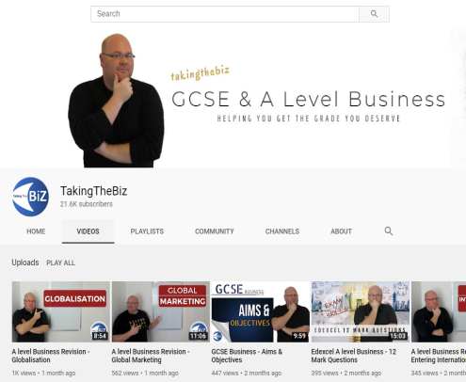
Taking the Biz
www.youtube.com/channel/UCIlJ4pk3uzyWoeoBkGs0hxQ/featured

TakingTheBiz is a YouTube channel dedicated to the provision of revision resources for students studying A Level (and GCSE) Business. The aim of TakingTheBiz is to provide students with a more visual, engaging and memorable revision aide to help them prepare for their exams. Each tutorial focuses on one of the key topics for the Business specifications.

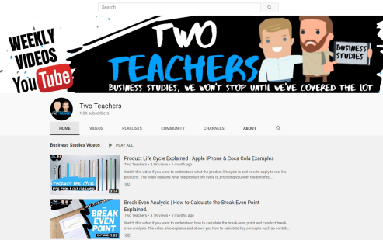
Two Teachers
www.youtube.com/c/twoteachers
Another YouTube channel dedicated to the provision of resources for students studying A Level Business. More emphasis on application of theory to different case studies in their videos.
- Other recommended reads
Quality newspapers / magazines such as: the Times, Guardian, Telegraph, Independent, journals such as The Economist (NB. there are reduced rates for students on some of these, for example, students were able to buy The Economist for 6p per copy instead of the standard £2!), and the Business Review magazine (available in the KES Learning Resources Centre or you can subscribe for your own student copy)
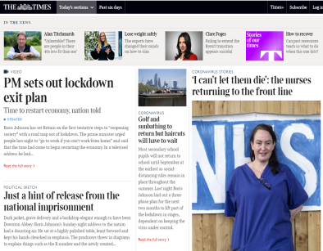  www.thetimes.co.uk | 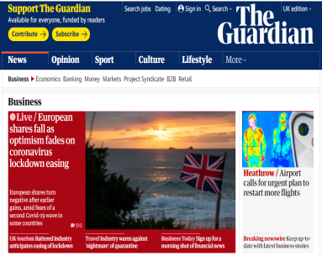  www.independent.co.uk | 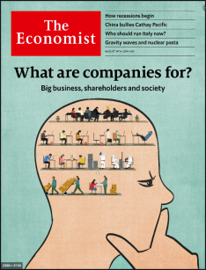  www.economist.com | 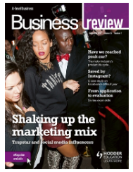  www.hoddereducation.co.uk/businessreview#!

- Get Reading
Business Books that you might enjoy reading include:
- Grinding it out
Few entrepreneurs can claim to have actually changed the way we live, but Ray Kroc is one of them. His revolutions in food service automation, franchising, shared national training and advertising have earned him a place beside the men who founded not merely businesses but entire new industries. This book tells his story.
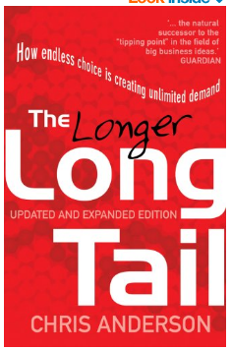
- The long tail / The longer long tail
The first book to really explain how the new world of internet based compaines worked and the reason why their new buienss modles were not only going to be successful but were better than the existing models and appraoches being used. Updated with the “longer” tail to givve further analysis and understanding
- The tipping point
Malcolm Gladwell has become a bit of a phenomenon with is accessible bestsellers explain complex / ,misunderstood ideas in simple and effective ways that help you get a better understanding of the world. In this book (which helped make the phrase “tipping tip” common) he looks into the reason’s products become market leaders.
- How I made it
An essential read for anyone that is thinking about starting their own business. Successful Entrepreneurs are interviewed about how the spotted a gap in a market, and developed a USP.
- The Google story
Its staff eats for free in a dining room that used to be run by the Grateful Dead's former chef, and its employees traverse the firm's colourful Silicon Valley campus on scooters and inline skates.
An interesting investigation into the culture at Google, includes insights into the four-day working week and soft management styles. The questions are; are these the things that made Google the world’s number one search engine?
- Shoe dog
In 1962, fresh out of business school, Phil Knight borrowed $50 from his father and created a company with a simple mission: import high-quality, low-cost athletic shoes from Japan. Selling the shoes from the boot of his Plymouth, Knight grossed $8,000 in his first year. Today, Nike's annual sales top $30 billion. In an age of start-ups, the Nike swoosh has become a revolutionary, globe-spanning icon, one of the most ubiquitous and recognisable symbols in the world today.
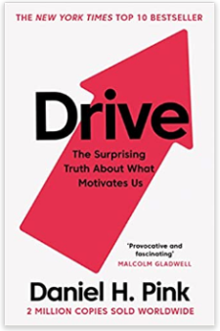
- Drive: The surprising truth about what motivates
Forget everything you thought you knew about how to motivate people at work (or at school or even at home). It is wrong! Daniel Pink guides us through the secret to high performance and satisfaction in today's world showing that motivation is deeply seated in the human need to direct our own lives, to learn and create new things, and to do better by ourselves and the world. Once you take money off the table you can learn how to motive your workforce to new heights
- One click
Amazon's business model is deceptively simple: make online shopping so easy that customers won't think twice. Much of it hinges on Jeff Bezos, the CEO and founder, whose unique character and ruthless business sense have driven Amazon relentlessly forward. This title charts Bezos' rise from computer nerd to world-changing entrepreneur.
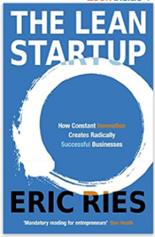
- The Lean Startup
The Lean Startup is a new approach to business that's being adopted around the world. It is changing the way companies are built and new products are launched. The Lean Startup is about learning what your customers really want. It's about testing your vision continuously, adapting and adjusting before it's too late.
Now is the time to think Lean!
- Get watching
Why not take some time out to what a few films that will help develop your business knowledge and understanding such as:
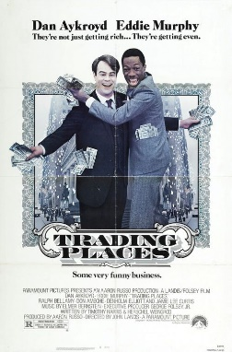 | Trading Places (1983): certificate 15  Trading Places is a 1983 American comedy film directed by John Landis and starring Dan Aykroyd and Eddie Murphy. It tells the story of an upper-class commodities broker and a homeless street hustler whose lives cross paths when they are unknowingly made part of an elaborate bet. A classic!  Business reference: Profit, Stock Market, Commodity trading , Business ethics
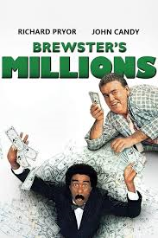 | Brewsters Millions (1985): certificate PG  After losing his position as a minor-league pitcher, Montgomery Brewster (Richard Pryor) learns his great-uncle has left him $300 million. To inherit it, Brewster must spend $30 million in 30 days under a complicated set of rules that forbid him from donating too much to charity or retaining any new assets when the period is up. Unable to share details about the will's odd conditions with anyone.  Business reference: Money, Assets
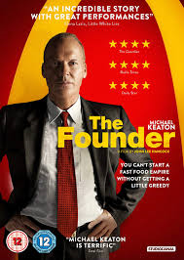 | The Founder (2016): certificate 12A  The true story of how Ray Kroc (Michael Keaton), a struggling salesman from Illinois, met Mac (John Carroll Lynch) and Dick McDonald (Nick Offerman), who were running a burger operation in 1950s Southern California. Kroc was impressed by the brothers' speedy system of making the food and saw franchise potential. Kroc soon maneuvers himself into a position to be able to pull the company from the brothers and create a multi-billion dollar empire.  Business reference : Franchising
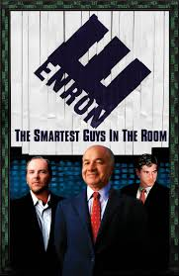 | Enron: The Smartest Guys in the Room (2005): certificate 15  The film examines the 2001 collapse of the Enron Corporation which resulted in criminal trials for several of the company's top executives during the ensuing Enron scandal it also shows the involvement of the Enron traders in the California electricity crisis.  Business reference: Profit, Public Limited Companies, Stock market, Insider Trading
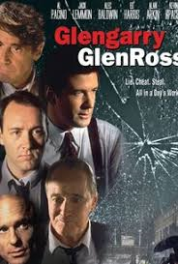 | Glengarry Glen Ross” (1992): certificate 15  This film follows the lives of four unethical Chicago real estate agents who are prepared to go to any lengths (legal or illegal) to unload undesirable real estate on unwilling prospective buyers.  Business reference: Profit, Motivation theroy

Or alternatively why not watch a few of the television programmes are that focus on business, such as:
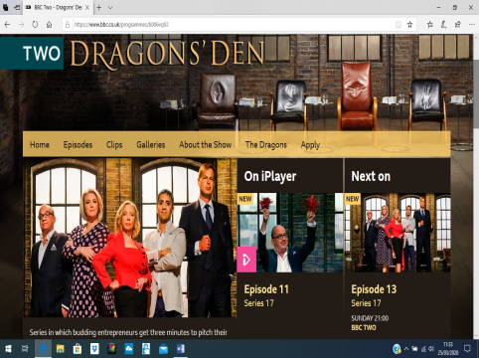 | Dragon’s Den  www.bbc.co.uk/programmes/b006vq92  Entrepreneurs pitch their business idea to the business “dragons” for investment and support  Excellent resource for understanding entrepreneurship and investment
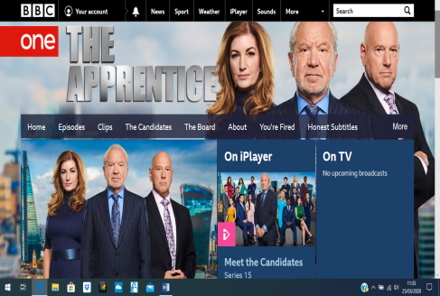 | The Apprentice  www.bbc.co.uk/programmes/b0071b63  Watch (just how badly) some people approach business tasks and then consider how much better you could have run the project (and that is before you have studied A level Busienss!)  Excellent resource for general business understanding, marketing team work
Undercover Boss
www.channel4.com/programmes/undercover-boss
High-flying executives take extraordinary steps to ensure their companies are fighting fit by going undercover in their own businesses.
Excellent resource for HR Management, business organisation and communication

Inside the Factory
www.bbc.co.uk/programmes/b07mddqk/episodes/guide
Gregg Wallace and Cherry Healey get exclusive access to some of the largest factories in Britain to reveal the secrets behind production on an epic scale.
Excellent resource for Operations Management and the role of production and distribution.

Channel Five’s ‘Inside’ Documentaries
www.channel5.com/show/inside/
- Inside Aldi
- Inside Cadbury
- Inside Harrods
- Inside Hamley’s
- Inside Rolls Royce
- Inside Waitrose
- Inside Nandos
Excellent resource for a general understanding of businesses
Activities to develop you business understanding
Have a go at the following tasks to start developing your business knowledge

TASK 1: “A week in Business”
Research the internet and select 7 pictures, one for each day, to represent a different business news story.
For each story, write a commentary / explanation to include the following:
- What is happening?
- What has it got to do with business?
- Why is it important?

Select the story that you found most interesting.
- Identify and explain the key feature of the story that grabbed your attention

TASK 2: a) Choose a Company / Brand and research it!
Find out the following about a company or brand of your choice or you could choose one from the grid below:
- Ownership type (Sole trader, Partnership, Ltd, PLC, Franchise)
- Revenue and Profit,
- Number of employees,
- Size and scale (number of stores, countries operate in, factories etc)
- Name of leader (CEO)
 | Snapchat
 | 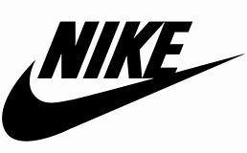 | 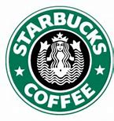
 | 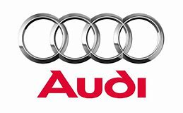
TASK 2: b) In depth business research

Now that you have a selected a chosen business, look to carry out some further in depth research.

Use the table below to help you identify what you should be looking for.

Basic business facts:
- Research the term “Annual Accounts for your chosen company” and download the PDF
- Read the chairman’s and CEO message at front of the pack or on their website
- Look through the pack to find the financial information (Income statement) this will show the revenue and profit.
Explain the following:
- What does the business do?
- How large is it?
- Where is it based?
- What are its key objectives? (Hint: look in the Chairman’s statement in the annual report)
How successful is the business?
Find evidence to support your view: eg.
- Sales revenue
- Profit
- Market share
- Brand recognition
- Stock market valuation
Has it become more or less successful over the last few years?
Compare data trends over a few years
What do you think are the key factors that affect its success and why?
Think about:
- Customer trends
- Competitors
- Government regulation
- the Economy
- the company’s financial situation etc.
AND FINALLY,
Evaluate what impact the coronavirus has on this business?
Look at:
- recent newspaper / news articles
- the company’s website
TASK 3: Entrepreneurs and Leaders

Research these business people
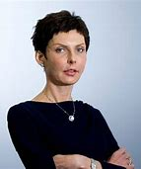  Denise Coates | Bill Gates | Evan Spiegel | Jeff Bezos
Elon Musk | Oprah Winfrey | 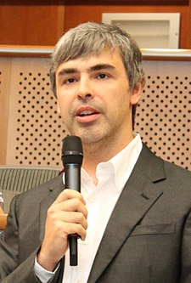  Larry Page | Simon Nixon
Kylie Jenner | 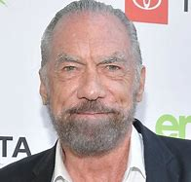  John Paul Dejoria | Sergey Brin | 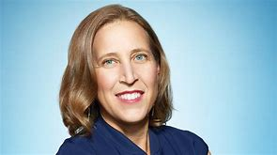  Susan Wojcicki

Find out the following about these entrepreneurs and leaders:
- What have they done?
- Why are they an entrepreneur?
- How did they do it?
- What is their net worth?
- What successes and failures have they had?

Then research an entrepreneur of your own choice.
- Why did you choose this person?

