A Welcome to the world of Accounting!
Below is a range of resources and activities prospective Yr12 A Level Accounting students can use to help prepare your Sixth Form studies.
Taking Accounting at A level is your first step into the highly respected global profession of accountancy.
Whether you are looking to go to university, run your own business or enter directly into the accounting profession the skill you will learn in your Accountancy A level hold you in good stead regardless of your career, role or level.
Given accountancy is such a specialist subject (and not one you will have studied before) it is not one that you can easily find out about or read around but below I have tried to guide you to some of the more relevant places that you can go to to “dip you toes” in the accountancy waters.
Have a look and see what interests you (and don’t worry too much it you don’t understand a lot to what you read / see – remember it takes years to be a fully qualified accountant!)

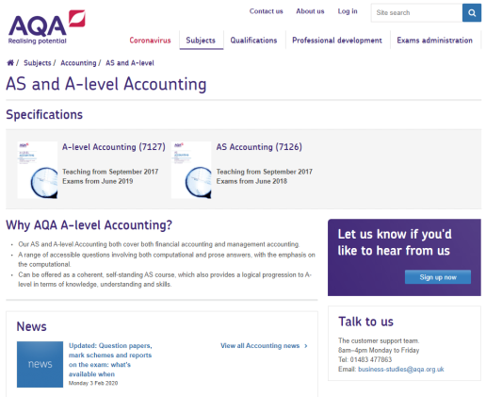
- For a look at the syllabus:
The AQA A Level Accounting Specification can be found at:
ocr.org.uk/qualifications/as-and-a-level/business-h031-h431-from-2015/
The examination specification plus past exam papers, mark schemes and examiners reports can be found on the AQA website

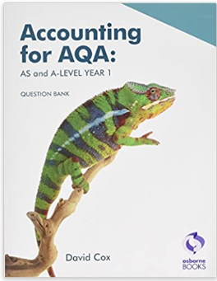
- For a look at the textbook:
The recommended textbooks (one for Yr12 and one for Yr13) are:
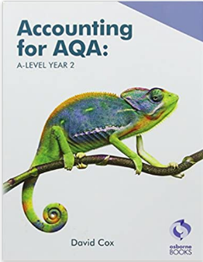
“Accounting for AQA: AS and A Level Year 1”
“Accounting for AQA: A Level Year 2”
Both by David Cox
https://www.osbornebooksshop.co.uk/p/accounting_for_aqa_as_a_level_year_1?_ga=2.134926962.2093472654.1589209747- 373569566.1589209747
https://www.amazon.co.uk/Accounting-AQA-Level-Question-Bank/dp/1911198130/ref=sr_1_3?dchild=1&keywords=aqa+accounting&qid=1589209755&sr=8-3

The textbook has been prepared for the AQA A Level Accounting course and can be bought form Osbourne books and (only recently) on Amazon.
- Online Resources
There are a few places you can go on-line to find (appropriate) accounting resources. The beset are:

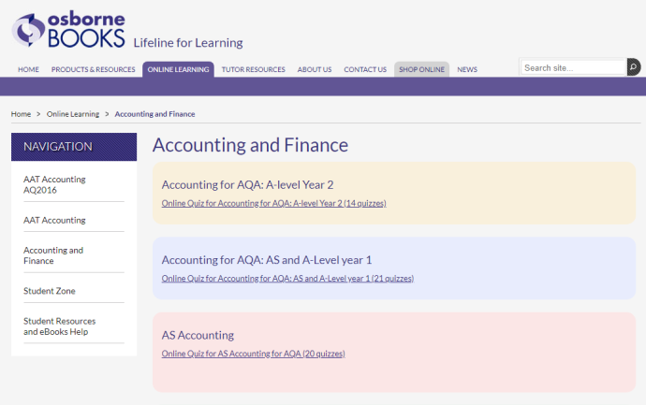
Osbourne books website
https://www.osbornebooks.co.uk/accounting_finance1
The Osbourne books website as an “on-line learning” section providing a number of mini test and quizzes on the theory covered in the AQA Accounting specification
(it also has an “student zone” which you can sign up to)

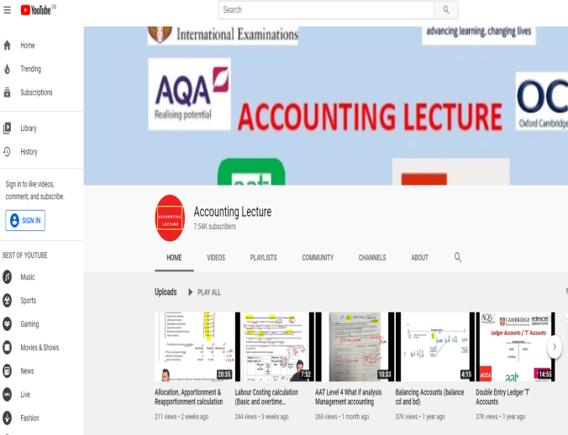
Accounting Lectures - Youtube
https://www.youtube.com/channel/UCFrY4HuR6uZpI7aG_fkQSAA/featured
Accounting Lectures present videos taking you through the basis theory of accounting as well as “walking” you though exam style questions.
The videos cover a whole range of levels from international GCSE, thorugh A level and onto the professional “AAT” (Association of Accounting Technicians) qualifications. This is one of the few places (other than in the classroom) where you can get to see how to approach accounting questions.

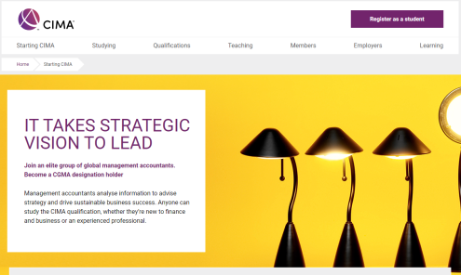
Accounting Profession websites
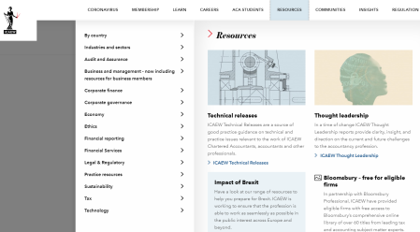
www.aat.org.uk/
www.icaew.com
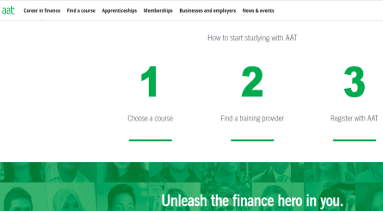
www.cimaglobal.com
The professional accounting bodies each have their own websites where yoe can find out about the profession and the accounting stories in the news

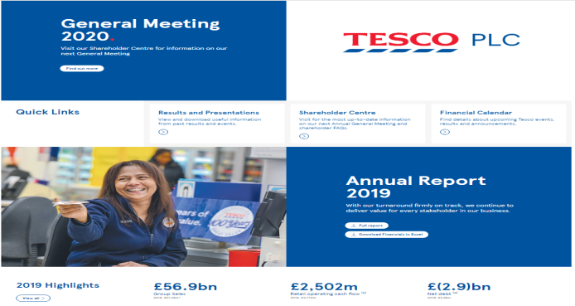
Business websites (eg. Tesco plc)
www.tescoplc.com/investors
All “Plc’s” (Public Limited Companies) and companies listed on the stock exchange) will have both their annual financial statements available to access giving the latest updates on their financial performance. Just go to their “plc” or “investors” links
Activities to develop you economic understanding
Have a go at the following tasks to start developing your economic knowledge

TASK 1: The UK Economy

Research the performance of some the UK’s largest companies
- Find out how the following five UK companies have performed over the last few years by going to their investor websites (and possibly even looking at their most recent financial statements).
- Plus add one company of your own choice
(it will need to be a FTSE 100 company use the link below to see the full list of the UK’s top 100 companies https://www.londonstockexchange.com/exchange/prices-and-markets/stocks/indices/summary/summary-indices-constituents.html?index=UKX)

Complete as much of the table as you can:
Tesco plc (supermarket)  www.tescoplc.com/about/key-facts/ | 2020 | 2019 | 2018 | 2017
Sales (Revenue / turnover)
Operating Profit
Profit Before Tax (“PBT”)
Current Share Price |  | Date of share price
Persimmon plc (house builder)  www.persimmonhomes.com/corporate/investors | 2020 | 2019 | 2018 | 2017
Sales (Revenue / turnover)
Operating Profit
Profit Before Tax (“PBT”)
Current Share Price |  | Date of share price
BP plc (oil extractor)  www.bp.com/en/global/corporate/investors.html | 2020 | 2019 | 2018 | 2017
Sales (Revenue / turnover)
Operating Profit
Profit Before Tax (“PBT”)
Current Share Price |  | Date of share price
Next plc (clothing retailer)  www.nextplc.co.uk/investors | 2020 | 2019 | 2018 | 2017
Sales (Revenue / turnover)
Operating Profit
Profit Before Tax (“PBT”)
Current Share Price |  | Date of share price
Just Eat plc (food delivery company)  https://corporate.takeaway.com/investors/results-and-reports/ | 2020 | 2019 | 2018 | 2017
Sales (Revenue / turnover)
Operating Profit
Profit Before Tax (“PBT”)
Current Share Price |  | Date of share price
Company of your choice  Name - plc | 2020 | 2019 | 2018 | 2017
Sales (Revenue / turnover)
Operating Profit
Profit Before Tax (“PBT”)
Current Share Price |  | Date of share price

TASK 2: Accounting theory
A) Read the following article explaining:
- What is a “Profit / Loss Statement” (income statement)
www.businessaccountingbasics.co.uk/profit-and-loss-statement

B) Watch the following videos from “Accounting Stuff” explaining:
- What is an Income Statement?
www.youtube.com/watch?v=hrSUq4wcd0g&list=PL5zKSeS09l339nB6ujJPQ9Rsv99_b-aTb&index=13

- What is the accounting equation?
www.youtube.com/watch?v=56xscQ4viWE&list=PL5zKSeS09l339nB6ujJPQ9Rsv99_b-aTb

C) Watch the following videos from “Accounting Lectures” to get a basic insight into:
- What is a “Debit” and what is a “Credit”?
www.youtube.com/watch?v=30YevNO5rvQ

- What is “T-accounting”?
www.youtube.com/watch?v=hJqgVxgHBGs

