DJB/py

January 2018

Dear Staff, Parents and Students

RE: GOVERNORS’ AWARD

This will be the third occasion that we are looking for nominations for our ‘Governors’ Award’. It will be awarded to students who have shown ‘excellence and commitment beyond the classroom’. The award should not be for participating in school sports teams or school music and performing arts as these are currently recognised through the colours system. It could be a student who has volunteered in the Library or at Saxon Hill, or to recognise sports beyond school. The award could also go to someone who has volunteered at a Brownies group or similar. This is not an exhaustive list and are just examples of possible ideas for nomination. It is a special award and students recognised as such must have shown real commitment to the cause over an extended period of time. The year before last we had 62 students from Year 7 to Year 13 that received this award. If any of these students have continued to show ‘excellence and commitment beyond the classroom’ we would welcome and encourage a nomination again for them.

Anyone can nominate: parents, teachers or students, although you cannot nominate yourself. To nominate, a short letter, no more than a side of A4, should be completed explaining who should receive the award and why. Nomination letters need to be handed to Bader Reception (FAO Mr Butler) by Wednesday 14th February 2018. A panel consisting of Senior Staff, Governors and Senior Prefects will sit to make a decision about who should receive these awards.

For any other information please visit http://www.keslichfield.org.uk/?page_id=7371

There will be no limit to the number of awards per year or Tutor Group. The award will be presented in a special afternoon assembly before Easter. Recipients will receive a certificate and an enamel badge, which can be worn on their blazer.

This is an award where we look to recognise all the good and highly valued things that students from King Edward VI take part in. We look forward to receiving your nominations.

Yours faithfully

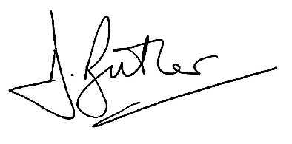

D J Butler
Assistant Headteacher (Head of Sixth Form)

