DJB/py

May 2018

Dear Parents/Guardians and Year 13 Students

ARRANGEMENTS FOR STUDY LEAVE AND THE EXAMINATION PERIOD

THIS IS AN IMPORTANT LETTER AND WE URGE YOU TO READ IT CAREFULLY.

After Friday 18th May 2018 you will be able to take study leave in order to make final revision preparations for your examinations. Whilst it is expected that the great majority of students will be able to use the time wisely at home, we are also offering a study facility at the school for those who wish to take advantage of this opportunity. In addition, you may be asked to come into school for final examination preparation in a number of subjects. As such you must abide by our rules.

1. STUDY LEAVE : END OF TIMETABLED LESSONS : FRIDAY 18th MAY 2018

Due to the early start of the examination period, special activities, including a formal final assembly will be held for all students instead on Thursday 28th June. Therefore students are expected in school for all normal lessons on this day. Leavers hoodies will be distributed at lunch in the Sixth Form common room. We remind students that hoodies CANNOT be worn to exams. Please ensure Clearance Forms are completed and handed into Mrs Patey-Round by Wednesday 16th May 2018.

2. YEAR 13 LEAVERS CELEBRATIONS DAY

Special activities including a formal final assembly will take place on Thursday 28th June 2018. It will include a novelty rugby match, brunch, book return and final assembly. Students will be expected in school at 8:55a.m. at the Sixth Form common room and will leave before lunch. After the activities, you are expected to leave the premises.

You will not be expected to wear normal Sixth Form uniform on this day. You can wear your leavers hoodies but need to be mindful that you are in a professional environment and as such should wear clothing that is appropriate.

As part of these activities you will hand in your textbooks and it is essential that school materials are returned for other students to use.

It is intended that the Leavers Celebrations Day will be a pleasant occasion since it is an important milestone for all. Sadly, however, a small minority have sometimes sought to mar the occasion by unruly behaviour. Apart from the general mess that can be left for cleaners and site supervisors to clean up, there is an additional reason why the orderly running of the school should not be disrupted: These activities coincide with the time when other students are in lessons. These students need to be able to continue with their education without unnecessary disturbance.

3. ARRANGEMENTS FOR HANDING IN TEXTBOOKS

The official date for handing in school books and materials is Thursday 28th June 2018 as part of the Leavers Celebrations day. It is important that all materials including lanyards are returned and we will need to charge for any school materials which you do not bring back. It is also important that you clear any debts for food with the school catering service.

If you are not going to attend the Leavers Celebrations day you must ensure that you return your materials and complete your clearance form in advance of this date.

4. STUDY FACILITIES AT SCHOOL

From Monday 21st May 2018, the Library Resource Centre will be available for any Year 13 student, solely for the purpose of private study during school hours. It is essential that a formal booking is made with the Librarian in advance as there are many other groups of students who use the research facilities, including taught classes. Students taking advantage of this opportunity should therefore be aware that discussions or any noise can be disruptive to others, so that it is a condition of using this facility that complete silence is observed.

6. SCHOOL UNIFORM

It is understood that FULL SCHOOL UNIFORM MUST BE WORN WHENEVER, AND FOR WHATEVER REASON, STUDENTS COME ON THE PREMISES DURING STUDY LEAVE. Students MUST sign in whenever in school in the usual way due to health and safety regulations.

7. PARKING
STUDENTS MUST PARK IN THE SIXTH FORM CAR PARK AND NOT PARK AT THE LEISURE CENTRE, ASTRO TURF OR BADER CAR PARKS WHEN COMING INTO SCHOOL ESPECIALLY DURING STUDY LEAVE OR FOR EXAMINATIONS.

8. PUBLICATION OF EXAMINATION RESULTS

- Results for Year 13 will be issued, from the Library between 8.30am and 11.30 a.m. on Thursday 16th August 2018. To get the results to you as early as this requires a considerable logistical effort, if we are a little delayed bringing the results to you please be patient.

- It would be wise for you to have your clearing instructions and contact telephone numbers with you when you come in. Don’t forget your UCAS number as this speeds up queries.

- Miss Williamson and Mr Hensley will be available in the library to offer advice should you need it on results day.

- Should you be asked to provide a copy of your UCAS reference for a university at very short notice, try to get an e-mail contact address. These are easier to deal with from home than fax numbers.

- If you are away from home when the results come out –
  - Make sure that you have provided a relative or trusted friend with a signed letter giving them permission to collect your results.
  - In case you have to go through the clearing process, give a parent very clear instructions on what would and what would not be acceptable to you. Sometimes important decisions have to be made during a telephone call.

9. PRIZE NOMINATIONS

Mr Youngs, a former Headteacher, endows a monetary prize for “All round commitment, service and endeavour”. Applications for this are invited from leavers. A written application, marked for the attention of The Headteacher’s Secretary, should indicate what you have contributed in three of the following five areas of activity:

1) Performing Arts (eg music, drama, backstage etc.)
2) Creative Arts (eg poetry, magazine writing, essays)
3) Sport (eg team sport at any level)
4) Service (eg house organisation, charity collection)
5) Duke of Edinburgh Award (Gold, Silver or Bronze)

We look forward to seeing you at Presentation Evening, which will take place during NOVEMBER of the Autumn Term of 2018. Please note : Invitation letters will be sent to your home address.

We wish you success in the future.

Yours faithfully

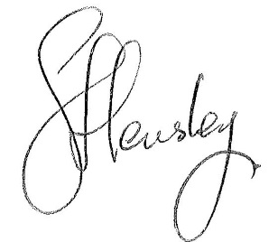
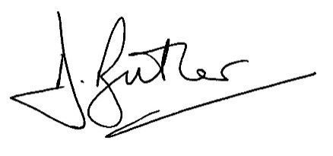
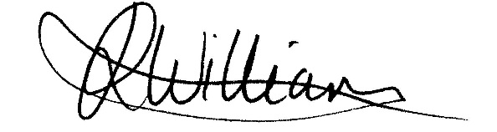

MR D J BUTLER MISS J R WILLIAMSON MR S HENSLEY

Assistant Headteacher/ Achievement Leader Assistant Achievement Leader
Head of Sixth Form Years 12 & 13 Years 12 & 13

