DJB/py

May 2018

Dear Parents/Guardians and Year 12 Students

I am writing with information about arrangements for the remainder of this term, mock and external examinations and the collection of external examination results in August (for a small number of subjects only).

- STUDY LEAVE
All students will have study leave from Monday 21st May to Monday 4th June. While it is expected that the great majority of students will be able to use this time wisely at home, we are also offering a study facility at the school for those who wish to take advantage of it. The upstairs area of the Library Resource Centre will be available for silent individual revision during this period. Some external examinations are before this period. If a student has an examination before study leave, they are entitled to take the half day before as study leave i.e. for a morning examination, periods 4 and 5 the day before may be taken as study leave and for an afternoon examination, the morning may be taken as study leave on the same day. Students must take the responsibility to inform their tutors of this and have their absence coded accordingly.

- PARKING
STUDENTS MUST PARK IN THE SIXTH FORM CAR PARK AND NOT PARK AT THE LEISURE CENTRE, ASTRO TURF OR BADER CAR PARKS WHEN COMING INTO SCHOOL ESPECIALLY DURING STUDY LEAVE OR FOR EXAMINATIONS.

- CONTINUATION OF STUDIES
When lessons begin again on Tuesday 5th June students will continue with their A level courses. For all courses, this is the continuation of two year A levels; therefore students are reminded of the minimum 96% attendance requirement to registration, tutor periods and lessons, along with the need for them to complete any necessary preparatory work for Year 13 over the summer holiday.

FAMILY HOLIDAYS SHOULD BE AVOIDED DURING THIS TIME AS SHOULD HOLIDAYS WITH FRIENDS.

- PUBLICATION OF INTERNAL AND EXTERNAL EXAMINATION RESULTS

i. Internal mock examination results will be available in school after all examinations and marking has taken place. The results will be shared before the end of term.

ii. Externally assessed examination results will be available from the Library Resource Centre on Thursday 16th August 2018 between 9:30am and 11:30am. Students who wish for their results to be handed to a third party should write a letter giving their permission to the person collecting the results envelope. If you are not intending on coming in on this day to collect your results due to unavoidable circumstances, please bring a stamped addressed envelope to the Exams Office so your results can be posted.

iii. Miss Williamson and Mr Hensley will be available in the library to offer advice should you need it on results day.

- CONDITIONS OF STUDY

The demands of A level study require a greater degree of commitment and level of understanding from students, therefore it is essential students obtain a pass in a subject in their Year 12 examination in each subject in order for them to continue their studies in each subject in Year 13. Students must achieve at least an E grade in a minimum of three subjects in order to progress into Year 13. Students will also need to demonstrate the necessary commitment to a subject in the remaining weeks of Year 12 if they wish to continue their studies in the next academic year.

Students need to also ensure they are wearing appropriate Sixth Form uniform during the Summer term. If worn, jeans must be black and not ‘washed out.’ Any tops worn should be suitable for a professional environment, therefore this excludes strappy, crop and off the shoulder tops for female students.

Best wishes to all in the forthcoming examinations.

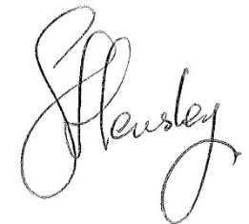
Yours faithfully

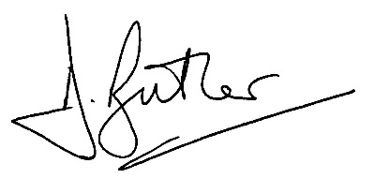
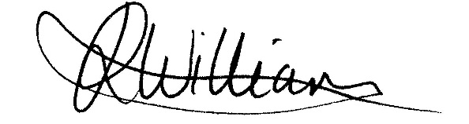

MR D J BUTLER MISS J R WILLIAMSON MR S HENSLEY
Assistant Headteacher/ Achievement Leader Assistant Achievement Leader Head of Sixth Form Years 12 & 13 Years 12 & 13

