3 January 2018

Dear Parent/Carer
We have arranged for the year 13 chemistry pupils to attend some evening lectures. They are at Birmingham University, Haworth Building, room 101 on Tuesday 16th January – Chirality, Smell, Drugs and Chemistry, Tuesday 20th March - Advanced level Revision: pH, buffer solutions and titration curves and Tuesday 24th April – Advanced level revision: Mathematics in Sixth form chemistry, all at 7:00pm. At the time of writing I am unsure of the actual finish time of the lecture unfortunately, I would assume this to be about 8 o clock, but will make pupils aware as soon as the university have come back to me. The purpose of this visit is to broaden pupils’ knowledge, understanding and interest in the subject, as well as aid their revision.
Pupils are required to organise their own transportation to and from the event, a member of staff will meet them at the venue, with whom they will need to register. The venue is a 3 minute walk from University train station, please see the attached map. Pupils are advised to travel in groups.
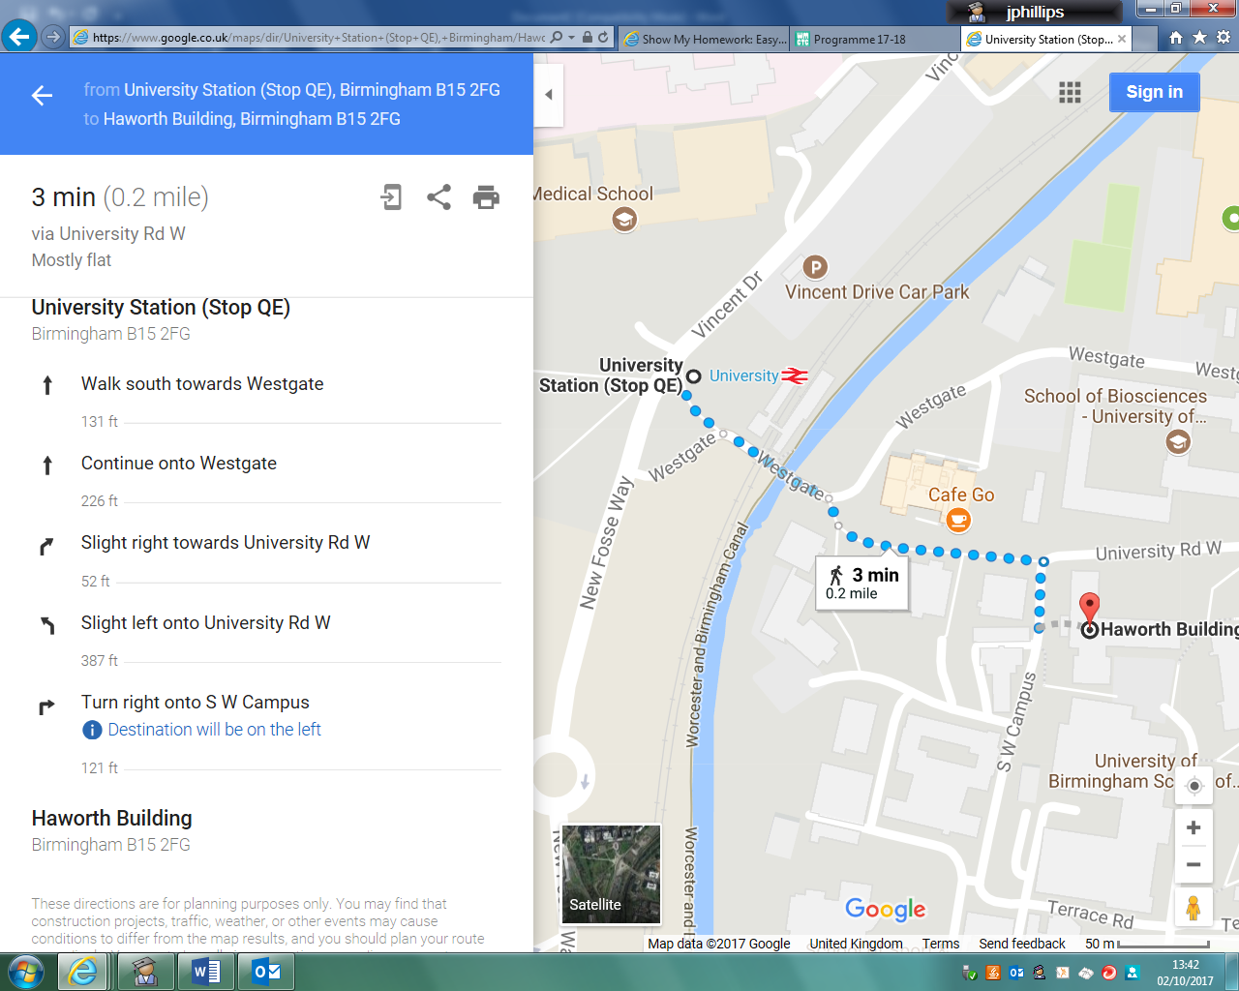

I have attached a consent form which I would be grateful if you could complete and return to Mrs Jetson in Bader Office at least 1 week before the lecture.
Yours faithfully
Mr J Phillips
Head of Chemistry

PARENTAL CONSENT FOR A SCHOOL VISIT
Please complete this form and return it to Mrs V Jetson, Bader Office

- Visit to Birmingham University Lectures on 16th January, 20th March, 24th April 2018
- Medical details. My son/daughter has the following medical or special needs. …………………….…………………………………………………………………………………….….……………………………………………………………………..……….……...………………………………………………………………………………………………………………………………..…………………………
- Dietary details. My son/daughter has the following dietary needs. ……………………………………..…………………………
…………………………………………………………………………………………………………………………………………………………………....………….
- Insurance. I understand the limits of insurance provided for this visit.
- Transport. I understand that my child is to make his/her own way to and from the venue.
- Photographs. Photographs taken on the visit may be used in school or education service promotional information. Please answer Yes or No …..…

I agree to my son/daughter attending the visit detailed above and I acknowledge that to be included he/she will need to maintain responsible behaviour

Name of son/daughter …………………………………………………..……….. Class ……………….……………………….…………………..……
Signed…………………………………………………………………… Date…………..………………………..………………..………….………… Person with Parental Responsibility
Once completed please return this form in a sealed envelope to Mrs Jetson in Bader Office.

