Week
1

,,

House point Focus

‘Well-presented work’

.

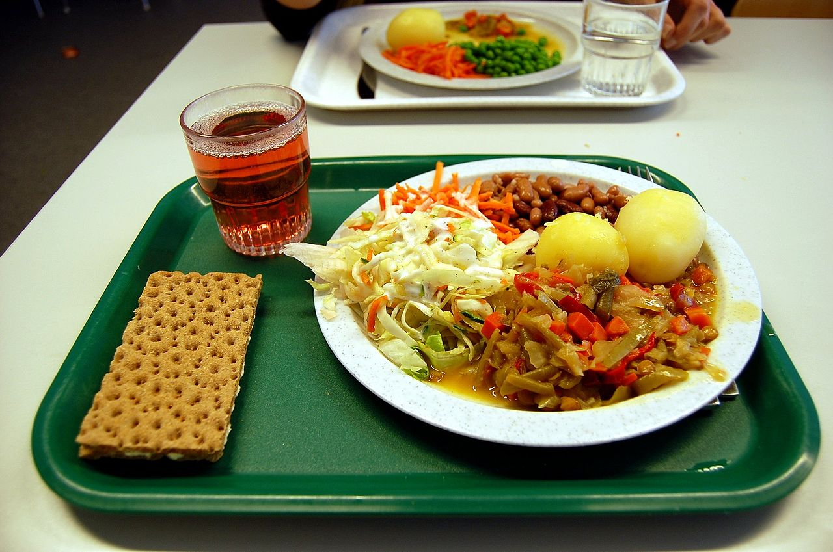

With the start of a new term and the start of a New Year just a gentle reminder to ensure you check your child’s cashless catering account is topped up.

If you arrive in school late for any reason then you must come to Bader reception to sign in. You should also have a note in your planner explaining why you are late.

If you have changed your mobile phone number over the Festive season, or your landline, place of work or address, please let us know in case of an emergency

Orangeboy by Patrice Lawrence (Shortlisted for the 2016Costa Book Awards)
Please note- not suitable for Year 9 and below
Not cool enough, not clever enough, not street enough for anyone to notice me. I was the kid people looked straight through. Not any more. Not since Mr Orange.
Sixteen-year-old Marlon has promised his widowed mum that he'll be good, and nothing like his gang-leader brother Andre. It's easy when you keep yourself to yourself, listening to your dead dad's Earth, Wind and Fire albums and watching sci-fi. But everything changes when Marlon's first date with the beautiful Sonya ends in tragedy; he becomes a hunted man and he has no idea why. With his dad dead and his brother helpless, Marlon has little choice but to enter Andre's old world of guns, knives and drug runs in order to uncover the truth and protect those close to him. It's time to fight to be the last man standing

CHEMISTRY CLINIC

Every Wednesday lunchtime in H2 pop in, bring your lunch and any topic that is causing you concern.

WINTER UNIFORM INFORMATION
Jumpers/Cardigans – please be aware that our uniform policy allows the following: Plain grey or black V-necked sweater or cardigan (without collar, zip or hood). Students must not wear any other type of garment under their blazers (including school PE hooded tops).
Students are permitted to wear a plain, dark outdoor coat over their blazers when the weather is poor. To retain students’ smart appearance camouflage-style combat clothing, pull over ‘hoodies’, leather/faux leather and denim are not permitted. (This includes clothing heavily decorated with insignia.) Wearing of sweatshirt-style zipped jackets is not permitted, as they do not offer adequate protection against cold/wet weather
A plain scarf in a dark colour is permitted. Football scarves are not permitted since they are out of character with school uniform Headwear should not usually be worn (apart from for religious/cultural reasons). In conditions of extreme cold a plain hat may be worn outdoors.
Headwear worn for cultural/religious reasons should be plain and black.

Please check the KES web site for all up-to date information
http://www.keslichfield.org.uk/
Even in the Winter during the school day it is important to drink plenty of water, there are several water fountains in school for you to get a drink during break or lunchtime. Bring your own drinks bottle and fill it up, however, getting a drink is not a valid reason to leave your lesson.

Holiday Dates-
Monday 20th February – Friday 24th February
Monday 10th April- Friday 21st April

For Your Diary
Staff Training Days
Wed 28th June 2017
Monday 24th July & Tuesday 2th July 2017

Early

MUSIC NOTICES – Winter TERM- Please check with the Music Staff
 | LUNCHTIME 12.35- 1.35 | AFTER SCHOOL 15:50-16:50
MONDAY | String group – Mr Brown  Percussion Ensemble – Mr Peverelle  Coursework Support – Mrs Ellse & Mr Jamieson
TUESDAY | 8.15 Barbieshop B3 Mrs Ellse  Brass Ensemble Brannon Room  Chamber Choir – Mrs Ellse  Junior Guitar Ensemble – Mr Rowley
WEDNESDAY | Flute Choir – Mrs Rowley  Course Work drop in – Mrs Ellse/Mr Jamieson  Keyboard Brannan Rom Mrs Cooke | Orchestra on Wednesdays, 3.45-4.30pm in B1
THURSDAY | Senior Choir- Mrs Ellse/Mr Jamieson  Junior Choir - Miss Bowen | Jazz Band 3.45-4.30 B1 Music Block
FRIDAY | FUSE – any instrumentalist – Mr Jamieson  Senior Guitar Ensemble – Mr Rowley
BOYS PE - Winter TERM - Boys Extra Curricular Practices/Matches
ALL team players are expected at practices. – CHECK FOR TIMES OF MATCHES ETC. WITH YOUR PE TEACHER
 | LUNCHTIME 12.35 – 1.35 | AFTER SCHOOL Matches & Practices
MONDAY | 1st XI Football (Week 1) – Mr Spruce (Field)  Year 10 Rugby Mr Tizzard (Field)
TUESDAY | Yr9/10/11 Basket Ball (November onwards  Year 8 Rugby – Mr Tizard (Field) | 1st XV Rugby – Mr Butler
WEDNESDAY | Yr 9 Football Mr Spruce (Field)  Yr 9 Rugby Mr Haigh (Field)  Yr 11 Football Mr Tizzard (November onwards)
THURSDAY | Yr 8 Football Mr Spruce (Field)  Year 10 football Mr Haigh (Field) | Badminton Mr Coombes/Mr Turner (Sports Hall)
FRIDAY | Year 7 Rugby Mr Spruce (Field)  GCSE Help Clinic – Rm 22

GIRLS PE - Winter TERM GIRLS CLUBS PRACTICES AND FIXTURES
ALL team players are expected at practices. – CHECK FOR TIMES OF MATCHES ETC. WITH YOUR PE TEACHER
 | LUNCHTIME 12.35 – 1.35 | MATCHES/PRACTICES After School
MONDAY | Week 1 U18 Netball Miss Pearson (Sports Hall)  Yr 7Y Netball Mrs Cobden (Courts/Gym)  Yr 9/10/11 Hockey Mrs Butler (Astroturf) | Hockey Club (Yr7-11) Boys & Girls Mrs Butler
TUESDAY | Yr 10/11 Netball Miss Robinson (Courts/Gym) | Yr 8/9 Netball for all – Sports hall  Hockey Coaching Clinic Mrs Butler
WEDNESDAY | Yr 8 Netball Miss Pearson (Sports Hall)  Yr 7X Netball Mrs Cobden (Sports Hall) | Yr 7 Netball – Sports Hall  Girls football – all ages (Astro)
THURSDAY | U14 Netball Mrs Cobden (Sports Hall) | Badminton Mr Coombes/Mr turner Sports Hall
FRIDAY | U16 Netball Miss Pearson (Sports Hall)  Yr 7 & * Hockey Mrs Butler (Astroturf)  GCSE PE – Sorts Clinic Mr Haigh

BADMINTON CLUB Badminton club will take place every Thursday @ 4.00p.m.until 5.00p.m in the Leisure Centre. If you wish to have your - Name put onto the waiting list please see Mr J Coombes Q3 or Mr N Turner Room Y1. Mr Turner/Mr Coombes
BOOK CLUB –For yrs 7,8 & 9 Every week on Wednesdays at 1pm (Make sure you have your lunch first!) Mrs Edwards/Mrs Grewer
I club has now turned into ‘Gifted and Talented club’ for KS3 & KS4 pupils. It’s on Wednesday 3:40-5, we have merged it with the KS4 Film Club too. Mrs Giles
Maths Out maths lunchtime support is:
KS3/4 support - Wednesday lunchtime - Q7 - KS5 Support - Tues - Thursday - M9 Miss K Walker
DRAMA CLUB -Drama Club is on Wednesday at beginning of lunch in Room 31 –open to all Y7,8 and 9 for fun and confidence building activities.
Creative Club is on Thursday lunchtime in Room 31 open to all Y7 where we will be doing all sorts of crafts, games, projects-have fun, make friends! Mrs Plant

HISTORY CLUB -History club will be meeting this year on Thursday at 12.40 in S13 and is open to all years. We will be doing a range of interesting activities and it will be great fun! All Yrs 7,8 & 9 particularly welcome Mr Bowman
Performing Arts Club – Tuesday lunchtime in Room 31. Mrs Plant
Gardening Club-Kings Hill House Wednesdays 12.45-1.25. Report to Mrs Davis in the house

DUKE OF EDINBURGH AWARD - Look out for notices during the year or speak to the DofE team.
Chess Club - Monday Lunchtime S13 (Mr Bowman’s room) all years welcome
KODU Club in Rm 22 Monday Lunchtime Mr Vyse
GEOGRAPHY CLUB - Thursday lunch time week 1 in S3 with Miss Merry. Open to Yrs 7 & 8. Quizzes, treasure hunts and skyping people from other countries and lots more. Miss Merry MFL Club -room 23 with Miss Page – check the schedule outside room 23 for dates (usually Tuesdays and/or Wednesdays)

