JRW/py

13th November 2017

Dear Parent/Guardian

RE: UCAS applications

Your son/daughter has registered to complete a UCAS application this cycle. I am writing to ask you to support your son/daughter in making their application by the end of term, December 19th, if they want their application to go on time. If students complete their application in the last week of term, beginning December 11th, we cannot guarantee that their application will be sent before the end of term. As you can imagine, a great deal of work goes into these applications and we cannot guarantee it will be completed in this short space of time. If you want the application of your son/daughter to be sent off before Christmas, please encourage them to complete their application before December 11th.

If your son/daughter has registered but decided they do not want to make an application this year, they need to come and see myself or Mrs Patey-Round to be deleted from the system. They will still need to request staff references for a general or UCAS reference in the future.

We run a session in school every Friday lunchtime in Y4 so students can have help with their application. Their tutor is also supporting them through registrations and tutor period. If they require any additional help they should contact one of the Sixth Form team.

I hope your son/daughter makes a successful application over the coming weeks. If your son/daughter has had their UCAS sent before you receive this, please ignore this letter.

Yours faithfully

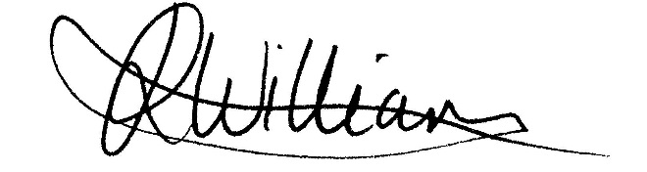

Miss J R Williamson
Achievement Leader for Year 12 and Year 13

