Transition Activity Pack
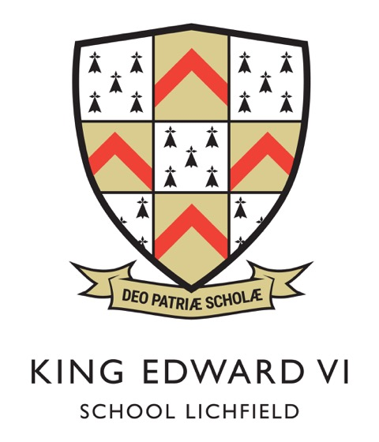
Due to the current situation, the inductions days for Y6 have had to be cancelled. We understand that these days are really important for Y6 and it will undoubtably cause a lot of uncertainty and nervousness as secondary school approaches.
Here are some activities for Y6 staff or Y6 parents to do over the next half term and summer to help support with the transition process. For those pupils in school, these can be led by Y6 staff. For pupils remaining at home, these can be led by parents.

We will keep you updated over the next half term and summer via email and twitter.
Miss R Thomas
Achievement Leader
TASK 1- student information pack

Read the information pack with your parents. Look at the subjects, rules, daily schedule, uniform, etc. How does it compare to your primary school? Using some of the aspects of school life, what are the similarities and differences between them from your primary school and KES? There are two extra aspects of school life for you to compare.
School life | My primary school | My secondary school
Timings of the day
Uniform
Subjects taught
Food
Clubs
Rules
Size
Are there any other differences you’d like to know? Tweet us @keslichfield_Y7 or email the school office@kingedwardvi-lichfield.staffs.sch.uk and a team of Y7’s will answer your questions.
TASK 2- Top 5

Transitioning to secondary school can be really exciting, but equally it can be a bit scary. How do you feel about leaving primary school and going to secondary school?

The 5 things I’m looking forward to the most at KES:
1.
2.
3.
4.
5.

The 5 things I’m nervous about the most at KES:
1.
2.
3.
4.
5.

Look at the transition page of the website. Scroll down until you find the top 10 concerns. Do your worries match the ones on the website? Read the advice given.

Are there any other worries you have? Tweet us @keslichfield_Y7 or email the school office@kingedwardvi-lichfield.staffs.sch.uk and a team of Y7’s will answer your questions.

TASK 2- continued

Read the pieces of writing from some of our current Y7 (on the next page). They give you honest accounts about transition to KES and I hope it alleviates some of your concerns.

Hi my name is Joseph and I started at King Edwards this academic year. I was looking forward to coming to King Edwards because they have lots of clubs, activities and nice food. I suffer from bad anxiety but have handled it really well. I already know my way around the school and am already doing activities I would not really do, like the Grease play but I really enjoyed it. I have already become a tutor rep which is part of the school council and have taken on many lunchtime and after school activities like: rugby, hockey, drama and possibly many more in the future. The teachers are really nice and I know I can trust them. Mrs Thomas who is the head of year 7 is a wonderful teacher and will help you out with anything. When I was in year 6 I would never have had the confidence to do this speech, but King Edwards has made me more confident. I am really looking forward to the future and all the new things what will be happening. Thank you for reading and I look forward to seeing you at KES
Hi my name is Macy and in September I moved from St Michael’s Primary School to King Edward VI School. Coming from St Michael’s, a school with less than 500 people, to a school with approximately 1500 people was one of my biggest worries but with the help of Mrs Dunn, my form tutor, I feel more confident when moving around this massive school. Surprisingly I already know my way around!
I really enjoyed the induction days as they gave me an insight of what life at secondary school is all about. I was given my first full tour of the school, got to meet my form tutor for the first time and did a few lessons which meant moving from class to class and following a time table, these two days really helped with the transition.
I decided to come into the school with a positive attitude and consequently, I have made some new friends and have been elected the role of Form Rep. As I move up through this school, I am going to try my hardest to keep that positive attitude and I look forward to the journey ahead.

I came from a small school with only one other person from my primary school. You may be worried and scared of coming to a big school and not knowing where you are, but everyone is nice and don’t be scared to ask people and teachers where to go. Within a week or 2 you will be fine and be settled in! Freya.

TASK 3- What should I do?

Read through the secondary school scenarios. Try to think about what you would do first, before looking at the answers.
Can you think of any more scenarios that you’d like answering? Tweet me @keslichfield_Y7

Scenario | Answers
‘I need to leave school at 11.40am as I have a dental appointment……’ | Bring a note to school in the morning and show it to your tutor who will sign it and give it back to you. At 11:35am (period 3) show the note to your teacher then go to Bader office and use it to sign out.
‘I’m late for school and first lesson has already started…’ | Report to Bader office and sign in BEFORE you go to your first lesson. You must sign into school and give a reason for your lateness.
‘I forgot to take my coat home yesterday and now I can’t find it…’ | Check any rooms where you might have left it. Then go to the staffrooms and ask to check the lost property bins. If you still haven’t found it, tell your tutor who can investigate and try the lost property room in Johnson at lunchtimes.
‘I forgot my packed lunch and haven't got any money with me……’ | If you don’t have money on your account, then go to Bader Office and explain the situation. They can then issue a dinner ticket for you to get some lunch. Remember to pay the money back the next morning.
‘I woke up with a bad cold and cough and don’t feel well enough to go to school……’ | A parent must phone the school to say you are not well. When you return to school, bring a note to explain your absence.
‘I have got a bad headache and feel sick. I am not sure if I can manage to go to my next lesson…’ | Go to your next lesson and tell the teacher. Try your best to keep going. If you really don’t feel well enough to stay they will give you a note to take to the office. The office staff will look after you and phone home if they think it is necessary.

TASK 4- ‘all about me project’

This is an actual task that we ask pupils to do every year for us. It has been put into the student information pack and your Y6 teachers also have a copy.

In September you will be assigned a form tutor who you will have for five years. A form tutor is a teacher who registers you every day and looks out for you. They give you messages, make sure you settle in well, track your attendance, behaviour and achievements. In order for them to get to know you better, they want you to produce a piece of writing that I all about you.
Your task is to produce an A4 piece of work (no more) under the title ‘All About Me’. It must be handwritten to showcase your literacy and handwriting skills but you can draw and include photos if you wish. Some ideas of what you might include are:

- Who are you and what’s your family like?
- What do you like to do outside of school? What are your hobbies?
- What do you want to achieve in the future?
- Where in the world would you like to visit?
- Who inspires you?
- What is your proudest achievement from primary school?
- What are you looking forward to doing the most at your new secondary school?

Handing in: Please complete this at home and send it back to King Edward VI school, along with other forms, using the envelope provided in the parent pack. Please ensure all work is named (first name and surname) along with the name of the primary school you attend.

TASK 5- the history of KES
King Edward VI School, Lichfield, was established over 500 years ago. It has a fascinating history on the Wikipedia page. Read and watch out for the following information:
- Where is the original school?
- When did the school stop being a grammar school?
- What or who are the four houses named after?
- What used to be Bader building?
- Why is it named Bader building?
- Which famous people once attended KES?

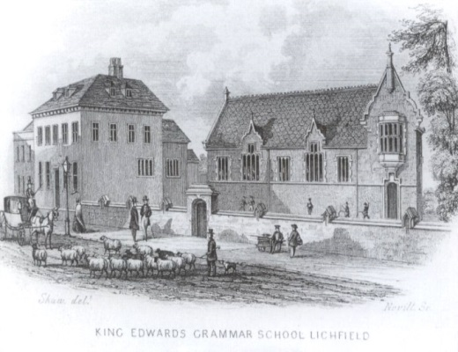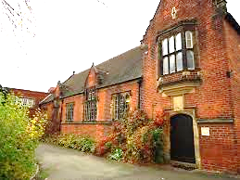
Do you know where this building is in Lichfield?

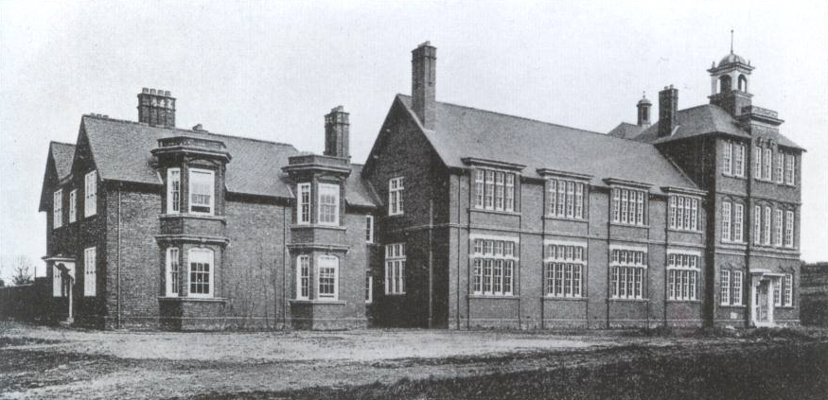
S-block building, Johnson. The old KES grammar school.

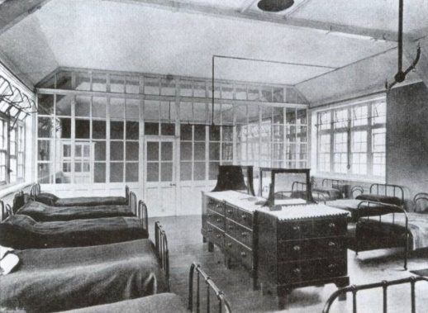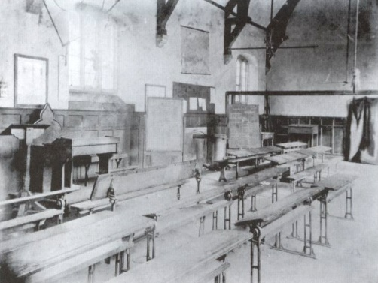
Inside S-block, Johnson building in 1903
TASK 6- Budgeting

Your parent/ carer has kindly given you a £5 budget for the day to feed yourself. What will you buy throughout the day for £5?

What if your budget is £3?

Here is a sample of our menu to help you.

Toast per slice 20p
Crumpet 30p
Bagel 30p
Bacon or Sausage Bap £1.60
Panini £1.80
Hash Browns £1.00
Chicken Wings £1.30
Hot Wrap £1.80
Pasta and sauce £1.60
Burger £1.80
Pizza Slice £1.30
Jacket Potato with one filling £1.50
Hot & cold puddings all 95p
Hot meal of the day Hot Meal of the day £1.95
Drinks start at 35p-£1.20

If you’re going to have a packed lunch, what will you have? Your breaktime isn’t until 11:35am so that’s a long time between breakfast and break. What will you have for breakfast to keep you going?

TASK 7- timetables

This is a sample timetable for Year 7. Remember it’s a two-week timetable.
- How many lessons a day do you have?
- How many different subjects do you have over the two-week timetable?
- What are the acronyms before the subject?
- What do the numbers mean next to these acronyms?
See underneath for the answers.

Answers:
- 5 lessons a day. Each lesson is an hour long. 25 hours a week.
- 15 different subjects over the two weeks
- The acronyms are the teacher’s initials. For example, JRP for Science is Mr J. R. Philips.
- The numbers represent the classroom. The classrooms in Bader are numbered 1-50. The classrooms in Johnson are slightly different. Q= q- block building. S= s-block building. H= h-block, etc.
TASK 8- the code of conduct
Every school has its own code of conduct or motto. Here at KES it is ‘ready, respect, strive’. When you break it down it covers some very important ways in which we would like you to behave at school. Do you agree with these principles? Would you add anything else? Do you think you could learn it all??

TASK 9- plan your journey

Your journey to primary school is probably quite short and I suspect most of you probably walk to school. Your journey to KES might be longer and you may not walk.
Plan your journey to secondary school. The post code is WS14 9DE. What route will you take? How long will it take? What time would you need to leave your house in order to arrive at school by 8:45am latest?
- Walking -use google maps to plan your walking route to KES
- Public bus- https://www.arrivabus.co.uk/midlands/
- Train- https://www.westmidlandsrailway.co.uk/
- School bus- see below for further details on this
There are several school bus routes that you can take to get to KES if you don’t live within walking distance. Details of each route can be found on the website to help you work out times.
128 - Swinfen, Weeford and Little Hay
K1 - Hints, Weeford and Whittington
K2 - Whittington
K3/K4 - Sutton Coldfield, Little Aston, Shenstone Woodend
K5 - Elford, Fisherwick, Hiddlesford
K6 - Swinfen Hall
K7 - Canwell, Little Hay

TASK 10- take a tour
KES is a big school split over two sites. There are also some exciting developments taking place over the next few years. Take a look at the school on google maps and take a walk around the grounds. Keep a look out on twitter for some video tours of the school. In the meantime, take a look at these drone images of the school.
Reception and leisure centre
Johnson
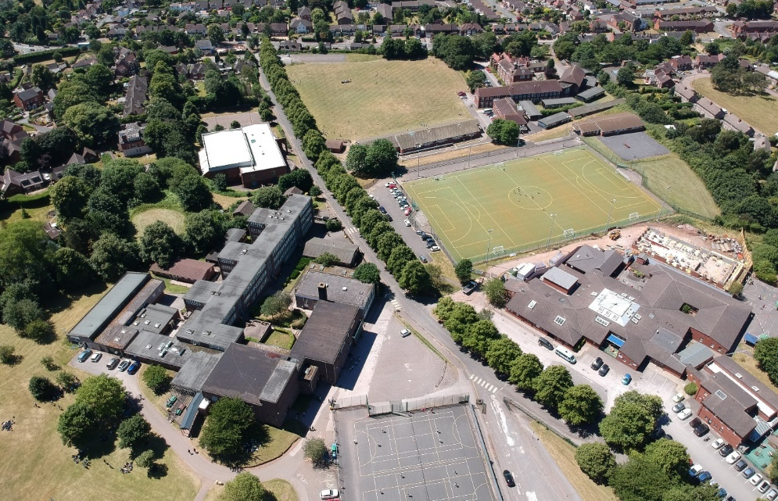
Saxon Hill School
Bader

Johnson
Upper St John street entrance to Johnson
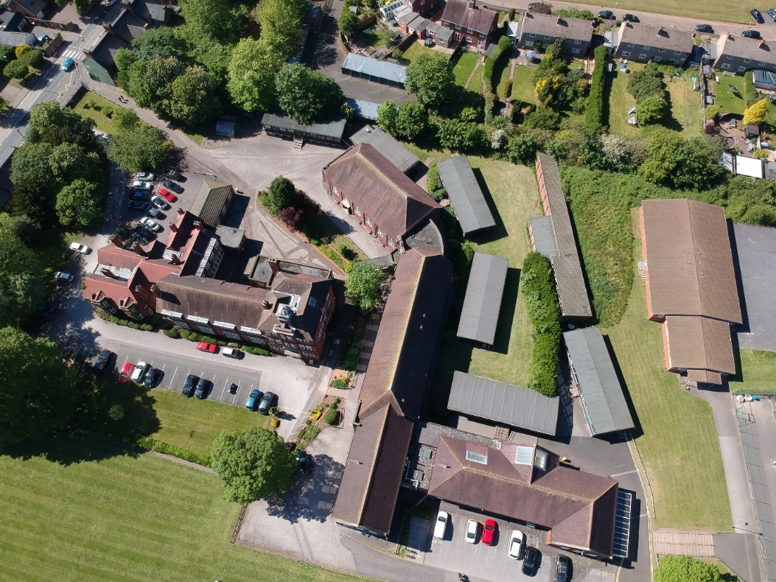
Y block- Sixth form
H-block- science labs
LRC
S-block; geography
Bader
Astro turf
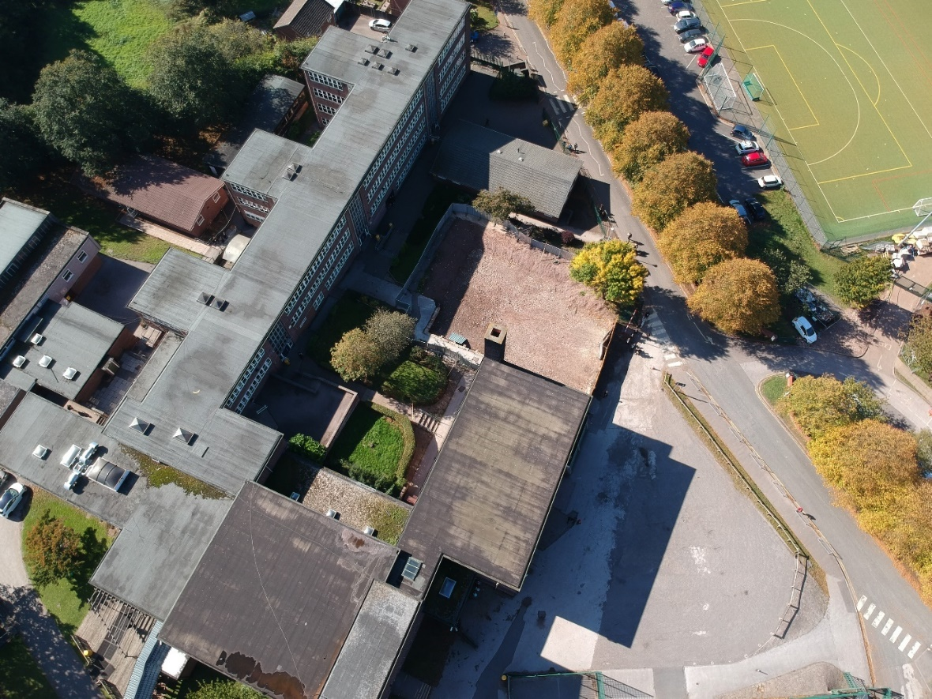
Lots of classrooms in Bader building
Canteen
Assembly Hall
Gym

Next to the leisure centre, before Bader:

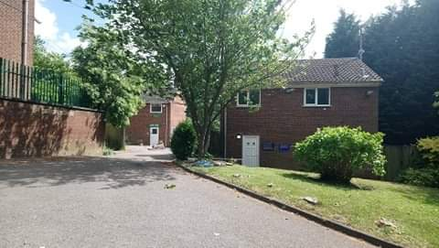
This house is used as our student support centre
This house is used as our learning support centre

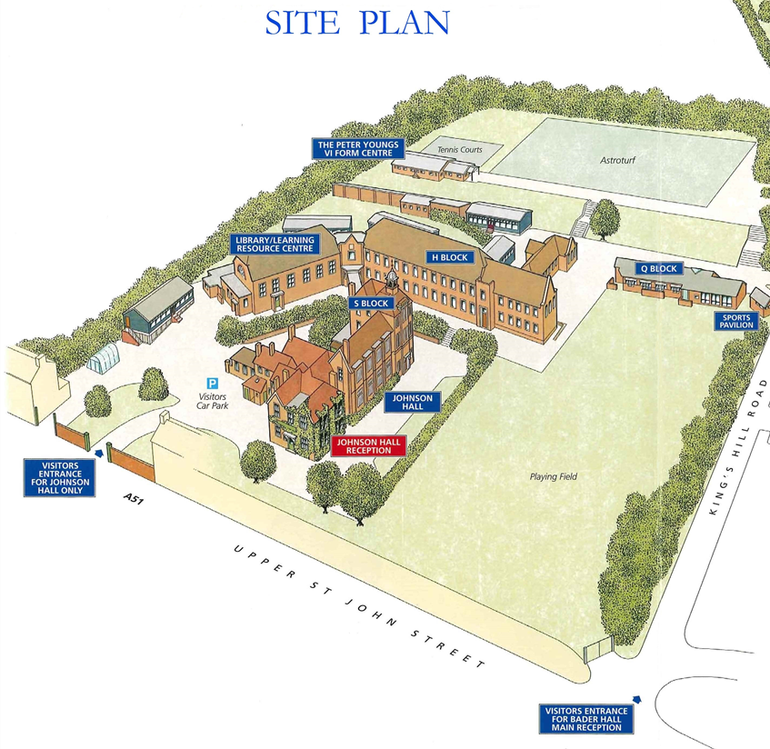
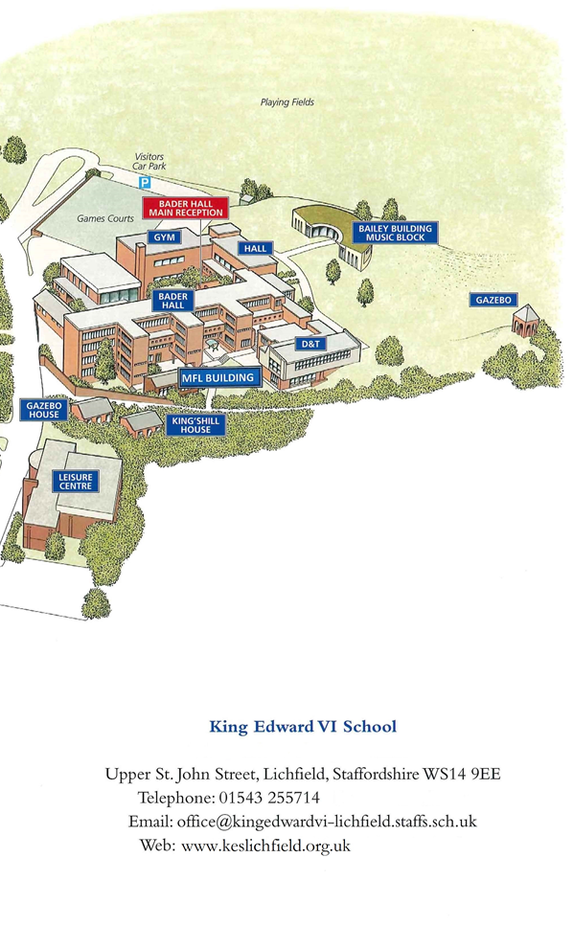
TASK 11- Guess the classroom
You will move between different subjects all day, every day because your subject teachers have their own classrooms. Can you guess what subjects are taught in these classrooms? Bonus points if you can locate them (Bader or Johnson)?
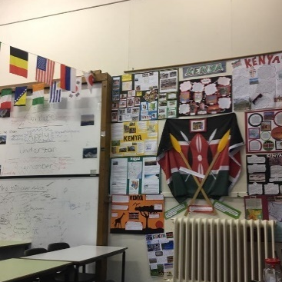 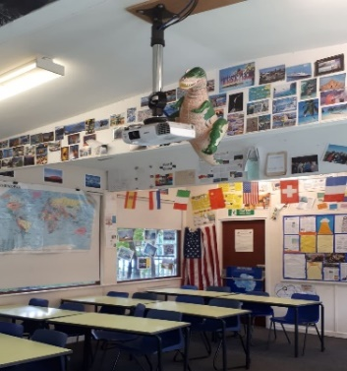 S1 Miss Merry & M2 Miss Thomas= _________
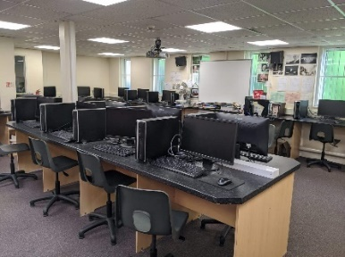 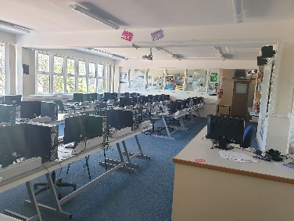 H1 Miss Burton & 22 Mr Vyse = ______
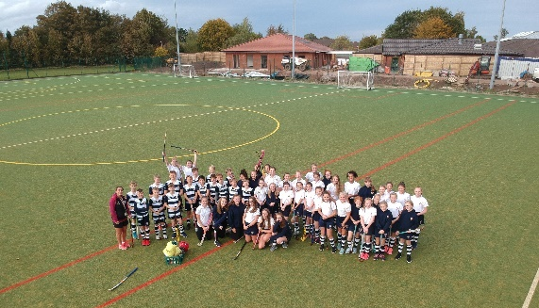 Astro turf- Mrs Butler = ___________
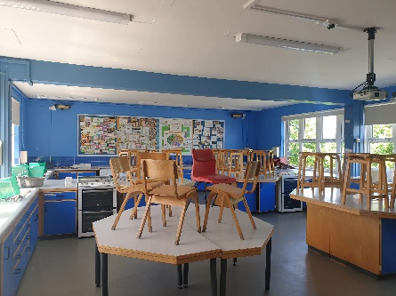 Room 39- Mrs Sheasby= ____________
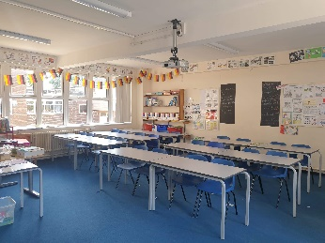 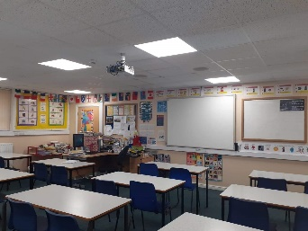 23 Frau Page and 40 Frau Dunn= _________
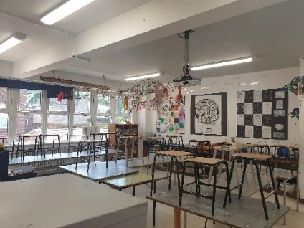 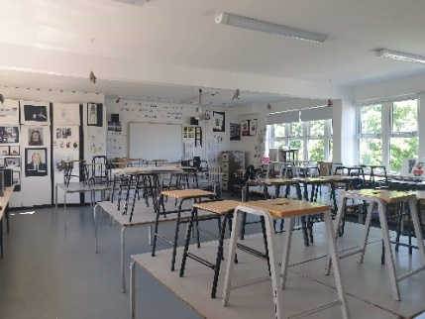 34 Mrs Watson & 36 Mrs Hill= _____
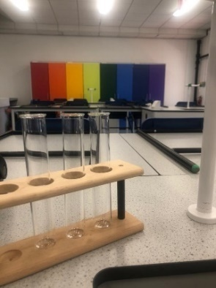 H3 Mr Hensley= _________
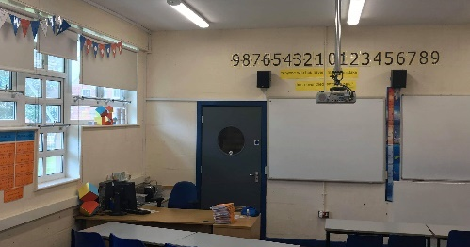 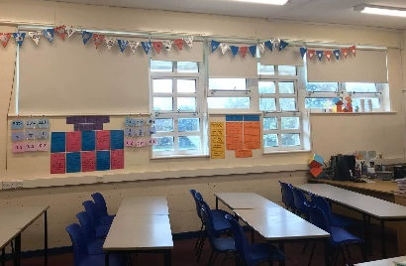 Q6 Mrs Cooper= ________

Look at the following images of various locations around the school. Answer the questions next to each image.
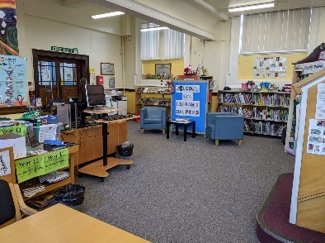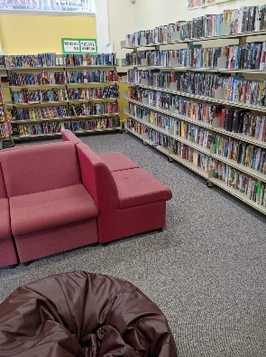
Aside from the obvious, what else can you use this room for?

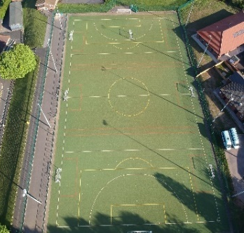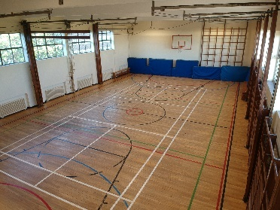
What different sports happen on these two facilities?
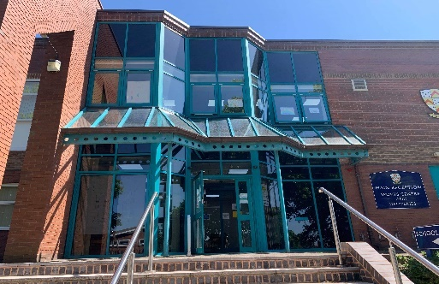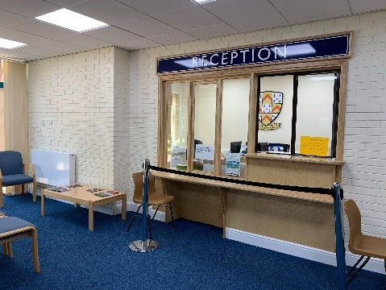
Our new reception has moved to where?
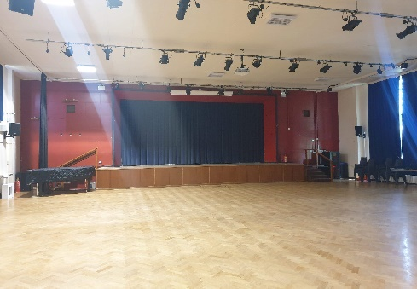
Once a week all of Year 7 will meet in here at 8:55am- what for? What else is this room used for?

We have two receptions at school. Who could this be one used by?
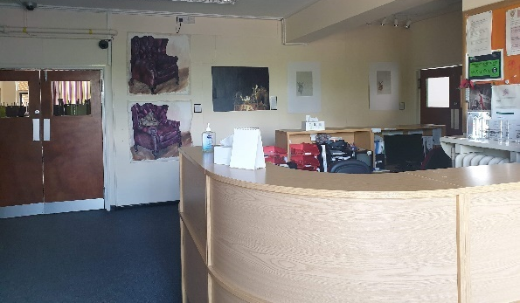
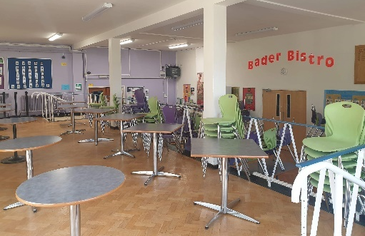
Probably my favourite place in the school, but where else can you get food?
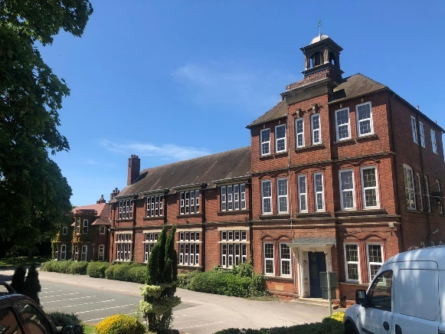
Where is this building? Do you know what this used to be and what subjects teach there now?
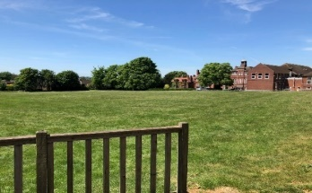
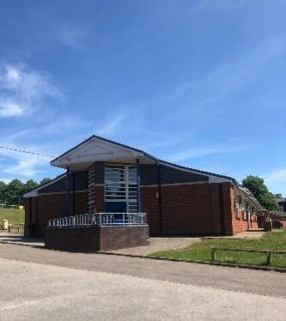
Outside of Q-block canteen there is this large field for you to play on. What other year groups will you share this with?
This is quite a modern building down in Johnson, what is it called and what do you find in there?
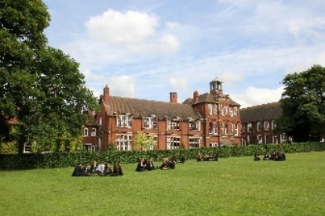

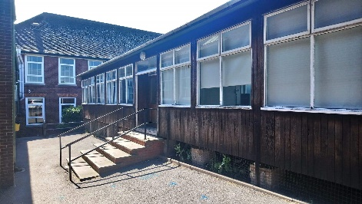
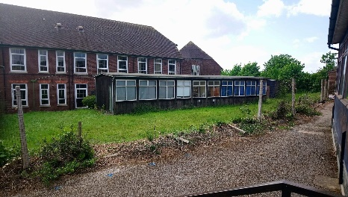
Spot the difference? Why are the mobiles going?
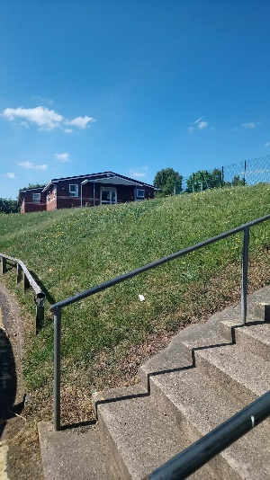
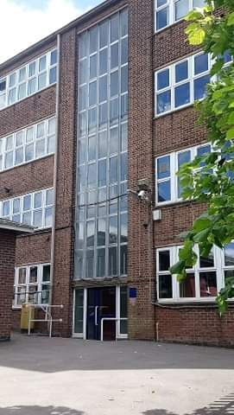
Up here is Y-block. Why aren’t Y7-11 allowed in?
How many floors and classrooms come off staircase 3 in Bader?
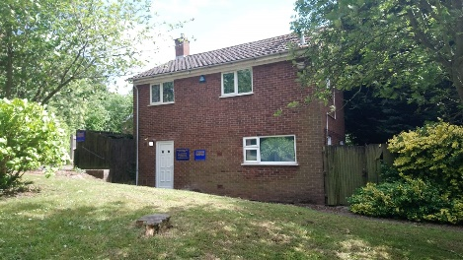
This house is student support. When would you need to visit here?
TASK 12- Work space

Find a place in your house where you will store your school books (you have a lot at secondary school). Where will you do your homework? Many homework’s require the internet. Will you have access to this? Don’t worry if not, mobile phones can do a lot these days or the LRC is open before and after school for you to use computers.

TASK 13- Equipment

Buy new stationary. You will not be provided with stationary at school. It is your responsibility to keep a well-stocked pencil case. Use the equipment list to help you. Go with your parent/ carer to buy this or help them choose it online. You will need also need a school bag big enough to carry up to five books and a PE kit bag.

TASK 14- Reflection
These are most certainly unusual times for all of us. It’s good to take some time to reflect on this experience; the good and the bad. Documenting our experiences is a nice way to reflect and can be kept for the future.
Get creative with this task (photo montage, power point, painting, story, poem, dairy, etc). Include all the things you have learnt, enjoyed, struggled with and felt upset by during this experience.
An example of my positives from this experience:
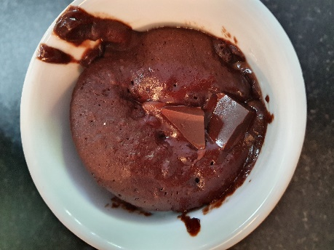
I haven’t baked since I was at school (shameful I know). But, during this time I have started to bake again and have really enjoyed it (and eating the goods!)
BAKING
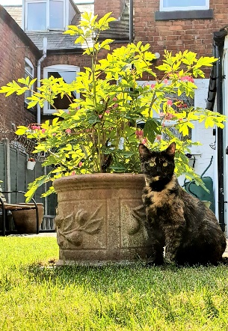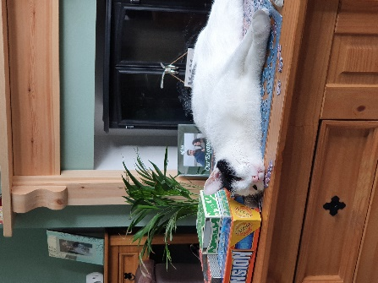
My cats keep me entertained daily! I’ve enjoyed evening snuggles with them
PETS
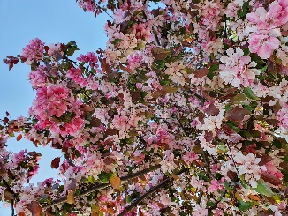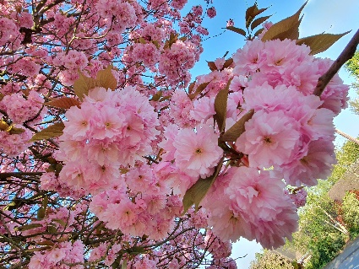
I never normally find time to exercise and since schools closed, I have really enjoyed going out for walks around neighbourhood. The flowers and weather have been beautiful and for this I am grateful.
WALKS
QUIZING
As a way of keeping in touch with my friends and family I have been quizzing and playing party games online! It’s been great fun to spend quality time with them and weird how I’ve probably seen more of them during this time than before! I’ve also learnt lots from all this quizzing! I do miss being able to hug people. My family and friends are going to get the biggest hugs ever when it’s allowed!

I hope this prepares you as best it can, given the circumstances.
Updates will be emailed and tweeted over the next few months.
Any further queries please email us office@kingedwardvi-lichfield.staffs.sch.uk or tweet us @keslichfield_Y7

I look forward to meeting you all in person soon.
Miss R Thomas

